Assessment Information
Client Name: | Example MS Word Report
 | 1 Arthur Road
 | Biggin Hill
 | Westerham
 | Kent
 | TN16 3DD
Client Contact: | Graham Thompson
Client Phone: | 00441689854690
Client Fax: | 00441689854690
Client Mobile: | 00447812183910
Client Email: | graham@oculusconsulting.co.uk
Site Name: | Example MS Word Report
 | 1 Arthur Road
 | Biggin Hill
 | Westerham
 | Kent
 | TN16 3DD
Site Contact: | Graham Thompson
Site Phone: | 00441689854690
Site Fax: | 00441689854690
Site Mobile: | 00447812183910
Site Email: | graham@oculusconsulting.co.uk
Assessor: | Oculus Consulting Ltd
 | 1 Arthur Road
 | Biggin Hill
 | Westerham
 | Kent
 | TN16 3DD
Assessor Name: | Graham Thompson
Assessor Phone: | 00441689854690
Assessor Fax: | 00441689854690
Assessor Mobile: | 00447812183910
Assessor Email: | graham@oculusconsulting.co.uk
Signature:
Date:
Risk assessment review date: 20/07/2012

Risk Assessment Scope
LEGIONELLA RISK ASSESSMENT SERVICES
The Legionella risk assessment carried out by Oculus Consulting Ltd on behalf of ########### will cover those systems for which we are contracted to assess. Any limitations of the assessment i.e. systems that aren’t included are stated clearly marked in the system identification.
Detailed clarification of the scope of the services to be supplied:
• The assessment is to cover all buildings at the detailed premises.
• The assessment is to identify & assess the water systems defined in our quotation only.
• The assessment will review existing schematic diagrams recording deviations on hard copy drawings only (where supplied).
• An asset register of all outlets will be produced.
• No specific site safety or other requirements (e.g. Induction training, etc) were identified in order to complete our survey.
• The written scheme IS NOT to be produced or supplied by the assessor, site specific control measures & corrective actions (see L8 para 52 to 78) are included.
• Presentation of the final assessment will be as electronic PDF format.
• The assessment will be received by the designated contact.
• Photographs where applicable will be used to highlight faults.
• The condition of system water and accessible equipment is to be determined, and the contribution to risk made by the design, construction and operation of the system and equipment is to be evaluated, and an asset register produced. (Condition Surveys)
• The written scheme is reviewed including the effectiveness of the control scheme and that significant deviations from acceptable operating conditions have been investigated and actioned.
• The ability of management to maintain control of the risk of Legionellosis is to be assessed
• The competence of site staff and contractors to control the risk of Legionellosis is to be assessed
Reporting
The content and output of the assessment will contain the following:
• Executive summary
• Scope of assessment, including clear identification of buildings systems and their use.
• Identification of key personnel, both staff & contractors, and their competence
• Identification of the risk systems
• Schematic diagrams will not be supplied (reference will be made to existing drawings).
• Results of condition surveys including: operating parameters, temperatures, system inspections, asset registers
• Review of written scheme
• Analysis and evaluation of risk for each system including an explanation of how the risk rating is derived
• Recommended and prioritised corrective actions to eliminate, minimise or lower risk
• The site and system specific control measures (monitoring, inspection & treatment, etc) including identification of sentinel outlets and or other relevant sample and inspection points
• Short term control measures to be applied until completion of corrective actions
• Long term control measures to be applied following completion of corrective actions.
• Precautions to be taken when testing, maintaining, etc low risk systems
• Matters or areas of evident concern beyond the scope of the assessment
• Sources of reference & guidance utilised (Further Information)
• The assessor experience and qualifications are supplied at quotation.

CLIENT COMMITMENTS & RESPONSIBILITIES:
It is the responsibility of the Duty Holder to ensure that:
• A legionella risk assessment is carried out and that it includes: all systems were water is stored or used in any premises controlled by the Duty Holder
• Consultation with employees, or their representatives, regarding the assessment is carried out. (See L8 paras 30 & 36)
• A Responsible person is appointed and is empowered managerially and financially to carry out their duties. (See L8 paras 39 & 44)
• A Risk Assessment review is carried out when required. (See L8 paras 27 & 38)
• It is the owner/user/operators responsibility to action: the findings of the risk assessment including the required corrective actions and implementation of the control measures, to create and implement the written scheme; and regularly review the progress of these activities.
• Provide a copy of any legionella risk assessment, control targets (e.g. temperatures, biocide levels), written scheme including escalation procedures, etc.
• Provide notification and any necessary instruction on known risks and safety requirements in the areas the service provider will be working e.g. access to asbestos register.
• Provide safe access and egress
• Provide contacts for communication and escalation

A complete Legionella Risk Assessment should include the assessment of all systems were water is stored or used in premises controlled in connection with trade business or other undertaking. (See L8 paras 18-38).

Additional Comments
FURTHER INFORMATION
Further information regarding Legionella Risk Assessment and control can be obtained from the following:

• National Guidelines for the control of Legionellosis in Ireland, 2009. Health Protection Surveillance Centre (http://lenus.ie/hse/bitstream/10147/84053/1/Legionellosis.pdf)
• HSE Approved Code of Practice and Guidance L8 – Legionnaires Disease, The control of Legionella bacteria in water systems. (http://www.hse.gov.uk/pubns/priced/l8.pdf)
• Safety, Health and Welfare at Work Act 2005.
• S.I. No. 248 - Safety, Health and Welfare at Work (Biological Agents) (Amendment) Regulations, 1998 (Amend S.I. No. 146 of 1994)
• S.I. No. 619 2001 Safety, Health and Welfare at Work (Chemical Agents) Regulations.
• BS8580: Water quality – Risk assessments for Legionella control – Code of practice
• BS 6700: 2006 – Design, installation testing and maintenance of services supplying water for domestic use within building and their cartilages.
• Health Technical Memorandum 04-01: The control of Legionella, hygiene, “safe” hot water, cold water and drinking water systems. Part A: Design, installation and testing. Part B: Operational management.
• Statutory Instrument 1992 No. 2225, The Notification of Cooling Towers and Evaporative Condensers Regulations 1992
• TM 13:2002 CIBSE Technical Memorandum - Minimising the Risk of Legionnaires Disease
• S.I. No. 278 of 2007 – European Communities (Drinking Water) (No. 2) Regulations 2007
• Thermostatic Mixing Valves Manufacturers Association (TMVA) Recommended Code of Practice for Safe Water Temperatures
• WMSoc: Guide to Legionella Risk Assessment.
• BIP 2177 Hot & cold water supply 3rd edition (http://shop.bsigroup.com/en/ProductDetail/?pid=000000000030189096)
• BS 7592:2008 Sampling for Legionella bacteria in water systems. Code of practice (http://shop.bsigroup.com/en/ProductDetail/?pid=000000000030161148)
• Blue book No 200 The Determination of Legionella Bacteria in Waters and other Environmental Samples (2005) - Part 1 - Rationale of surveying and sampling (http://www.environment-agency.gov.uk/static/documents/Research/book_200_1028650.pdf)

Table of Contents
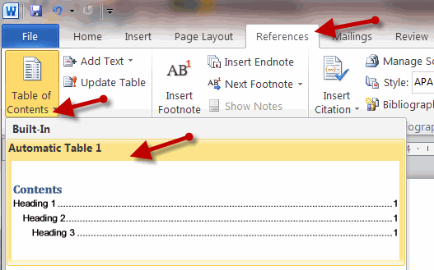
To insert an automatic table of contents at this point in the document go to the ‘References’ tab (MS Word 2010) and select ‘Table of Contents’ button and ‘Automatic Table 1’. This text should be deleted.

Executive Summary
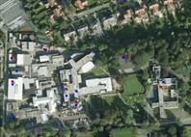

Site Description

~NAME~ Hospital has around ~NUMBER~ Inpatient beds, ~NUMBER~ Day Ward, ~NUMBER~ Endoscopy and ~NUMBER~ Oncology Day places. ~NUMBER~ Major and ~NUMBER~ Minor Operating Theatres and a comprehensive range of ancillary diagnostic, treatment and support services. The building has expanded from a convent to a hospital (~DATE~) and been subject to progressive refurbishment and expansion. Much of the main hospital water systems still present appear to have been installed in the early ~DATE~ these have been extended and modified. New buildings and refurbishment took place around ~DATE~ so the hospital has grown and has areas ranging greatly in age.

The Systems
A large part of the hospital is fed from a centralised hot and cold water system. Mains water is boosted to two large cisterns and dosed with Chlorine Dioxide within the mains riser. The cold water is then distributed in under floor ducts running below many of the main corridors to the OPD and ward areas.
Units 4,5 and 6 have been added and have a local cold water cistern and hot water heater.
Units 7 and 8 have been added and have a local cold water cistern and hot water heater.
The education building has a dedicated cold water service.
The Laboratory, Lodge and facilities management buildings all have dedicated hot and cold water services.
The old house has a number of de-commissioned cisterns but an old lead lined unit and water heater still appear to be serving a few outlets in the admin area.
An artificial water feature is present near the laboratory and wards.
Several heating and chilled water systems were noted.

The Management
A water safety management policy document was supplied to us at the time of our survey. A great number of the management failings often pointed out during a risk assessment are covered in this document. Management therefore have a sound written base for controlling legionella at Example MS Word Report. This risk assessment has identified a number of water systems and the interaction between these along with better mechanical drawings is still yet to be completed.

Management
Risk Ratings | 4 | 3 | 2 | 1
Number of items that require attention - Legionella risks | 0 | 7 | 7 | 2
Number of items that require attention - General risks | 0 | 0 | 0 | 3
All areas Management survey summary –
- Plumber and contractor training in legionella awareness may help to minimise dead ends and problems in the future, the practice of adding or removing sinks needs to be taken one step further to consider the system.
- ACoP L8 requires procedures what it calls normal operation such as instructions for commissioning, shutdown, checks on warning and diagnostic systems, maintenance requirements and operating cycles.
- Obtain evidence of your service provider training and assessment of the competence of individuals working on-site. Also hold formal review meetings with your service provider at least annually. Specialist service providers should provide defined allocation of all tasks within their service agreements. (The LCA requires service providers to detail also tasks that remain the client responsibility).
- Although we have produced simple sketches to understand the systems a more detailed layout is needed in order to understand the water system and make management decisions if problems occur.
- Consider how management would demonstrate they have legionella training and are competent.
- We feel site should check Chlorine Dioxide and sensor readings at weekly intervals recording results.

Cistern (Tank)
Risk Ratings | 4 | 3 | 2 | 1
Number of items that require attention - Legionella risks | 0 | 14 | 32 | 24
Number of items that require attention - General risks | 0 | 1 | 8 | 13
Main hospital T01 & T02 –
The cistern should be relined or replaced due to the significant levels of corrosion found. While many operational problems need to be overcome with the number of faults present replacement of these cistern would provide the best long term cost effective action for the hospital.
Dirty utility cistern T03 –
As the cistern is storing more than 1000 litres of water the lid should be constructed so that the cistern may be inspected or cleansed without wholly uncovering the cistern. A tight fitting inspection hatch should be installed.
The float valve is letting past and the cistern is over flowing lightly.
The cistern needs to be cleaned and disinfected in accordance with ACOP L8.
The cistern appears over sized. Water turnover needs to be established and if not adequate steps taken to reduce storage or improve turnover possibly by reducing the operating level.
Old house area T04 –
Disconnect and remove the cistern together with any redundant pipe work and water services. The services fed can be supplied by the main cisterns.
Education building T06 –
The cistern needs to be replaced with a new water reg compliant cistern incorporating all other recommendations made here.
Units 4, 5, &6 T07 –
A new lid and inspection hatch is needed with minor other works.
The cistern needs to be cleaned and disinfected in accordance with ACOP L8.
The total stored capacity appears to be over sized. Water turnover needs to be established and steps taken to improve turnover within this cistern.
Units 7&8 T08 -
The cistern needs to be cleaned and disinfected in accordance with ACOP L8.
The cistern appears over sized. Water turnover needs to be established and if not adequate steps taken to reduce storage or improve turnover.
Facilities management T09 –
The cistern needs to be cleaned and disinfected in accordance with ACOP L8.
A rigid close fitting lid should be fitted along with a few other minor improvements.
Laboratory T10 –
Due to the external location the cistern is externally rether dirty. A clean would reduce the risk of debris entering the cistern during inspections.
The cistern needs to be cleaned and disinfected in accordance with ACOP L8.
Lodge roof top T11A and B –
Water turnover could present an issue if the lodge is under occupied. Water meter readings allow turnover to be monitored. Usage much below 11m3 per day would indicate over capacity.
The cistern needs to be cleaned and disinfected in accordance with ACOP L8.

Calorifier (Water heater)
Risk Ratings | 4 | 3 | 2 | 1
Number of items that require attention - Legionella risks | 0 | 3 | 11 | 12
Number of items that require attention - General risks | 0 | 0 | 2 | 13
Old house area Cal03 –
If the unit fed patient areas we would have issued a risk rating of 4. The heater should not remain working at this temperature. Remove the water heater and connect any served outlets to the main HWS running close to the same locations.
Units 4 - 5 & 6 1st floor Plant room CAL04 –
The water temperature at the base of the water heater is much cooler than the water temperature at the top. A shunt pump to move hot water from the top of the calorifier to the base should be fitted.
The thermostat setting should be adjusted as the water heater is operating slightly above target temperatures. This may cause a scalding risk.
Units 7 & 8 Cal05 –
No significant recommendations made.
Facilities management Cal06 –
A few minor recommendations have been made.
Laboratory Cal07 - Fit thermometer pockets or temperature gauges on the water heater.
A few minor recommendations have been made.
Units 7&8 Rear Plant room CAL05 –
A few minor recommendations have been made.

Basement plant room Lodge CAL08, 09 & 10 –
The isolated water heater will create stagnation between the flowing circuit and the closed valves. The water heater should not remain off-line permanently.
Check the operation of the secondary system circulating pumps as at present they don't appear to be running? (Water temperatures in the return were satisfactory).

Direct mains services (MCW)
Risk Ratings | 4 | 3 | 2 | 1
Number of items that require attention - Legionella risks | 0 | 0 | 2 | 1
Number of items that require attention - General risks | 0 | 0 | 2 | 1
Mains water distribution -
Backflow is a real possibility with a pump directly fitted to the main supply. Connections such as those outside Education building area are a concern and should not be allowed. (See photo). Direct mains pumps are not generally allowed in the UK and are subject to approval by Dublin council in Ireland. Where possible a break tank should be used.
The large cast iron pipe work and fittings should be replaced with those constructed of WRAS approved materials as improvements are made. The main is likely to be in poor condition and could have significant debris in low flow areas.
As mains pipes are upgraded or refurbishment takes place better insulation should be fitted to the distribution system.
Defined drinking water outlets need to be labelled so that they can be readily identified.

Cold Water Down Services (CWDS)
Risk Ratings | 4 | 3 | 2 | 1
Number of items that require attention - Legionella risks | 0 | 1 | 3 | 1
Number of items that require attention - General risks | 0 | 0 | 0 | 1
All CWS distribution services. -
Some risk assessors recommend flushing of fire hoses on a regular basis to avoid stagnation and dead legs when they are attached to the mains distribution system. If flushing is undertaken, or considered possible, aerosols must not be produced during flushing. Consider installing a double check valve on fire hose connections.
Inadequate insulation needs to be replaced to meet the requirements of ACOP L8 as areas are improved.
Flexible hoses fitted after TMVs have recently shown to be a risk. Please see the enclosed document. The asset register has recorded areas where we noted flexible hoses. If these areas yield poor results the hoses should be considered as possible sources.
Dead legs identified on the schematics and the asset register should be removed.

Hot Water Down Services (HWS)
Risk Ratings | 4 | 3 | 2 | 1
Number of items that require attention - Legionella risks | 0 | 2 | 0 | 1
Number of items that require attention - General risks | 0 | 0 | 0 | 1
HWS Outlets and system –
Dead legs should be removed as identified on our schematic drawings. The flow and return circuit is not operating and has created large dead legs under units 1 and 2. The end of the line has been capped, this requires attention.

Water Features
Risk Ratings | 4 | 3 | 2 | 1
Number of items that require attention - Legionella risks | 0 | 0 | 4 | 1
Number of items that require attention - General risks | 0 | 0 | 0 | 0
Water feature outside –
Where the risk would normally be very low the susceptibility of individuals at this site makes this system a potential risk system. As high risk individuals are present the water feature should be operated with minimal aerosol production around areas where the water returns to the pond. From a pure Health and Safety view the need to produce splashing should be assessed, if there is no need then the risk even a low risk could be removed.
Temperature monitoring checks, in order to establish if water exceeds 20°C, should be carried out during summer months. If temperatures rise we would recommend that splashing is avoided until temperatures are acceptable. Monitoring for legionella would be applicable if temperatures exceed 20°C during warmer months.

Plate Heat Exchanger
Risk Ratings | 4 | 3 | 2 | 1
Number of items that require attention - Legionella risks | 0 | 2 | 1 | 1
Number of items that require attention - General risks | 0 | 0 | 0 | 1
Main Hospital Cal01 & 02 –
As temperature is used as a the main means of control, each vessel should deliver water at a temperature of at least 60°C (ACoP L8 Para 152). The heat exchangers do not appear to be performing well enough to deliver these target temperatures. (Please see additional comments supplied separately).
Surprisingly the base of the buffer vessels was found to be cold. This could be avoided by altering the position of the draw off point for the feed to the heat exchangers.

Understanding Risk Assessment
''A risk assessment is an important step in protecting your workers and your business, as well as complying with the law. It helps you focus on the risks that really matter in your workplace - the ones with the potential to cause real harm'' (Health and Safety Executive INDG163 rev2).
This risk assessment uses basic definitions:
- a hazard is anything that may cause harm, such as chemicals, electricity, or Legionella bacteria;
- a risk is the chance, high to low, that someone could be harmed by Legionella or other hazards noted multiplied by the severity. Since Legionella infections are serious (even fatal) the severity factor is always high.

Risk Assessment Responsibilities
The responsibility for implementing and completing the corrective measures remains with the Statutory Duty Holder or nominated Responsible Person. We would recommend that you read at least the following sections of HSE ACoP L8 Legionnaires' disease. The control of legionella bacteria in water systems: -
- (Paragraphs 39 - 51) Managing the risk management responsibilities, training and competence.
- (Paragraphs 52 - 65) Preventing or controlling the risk from exposure to legionella bacteria.
- (Paragraphs 66 - 69) - Record keeping.

This can be down loaded from http://www.hse.gov.uk/pubns/priced/l8.pdf
Failing to action the findings of a risk assessment may result in Legionella bacteria proliferating in the water systems inspected. Legionella is potentially fatal.
The use of L8MS-Risk software does not negate the responsibility of the service provider to ensure the Risk Assessor is competent to undertake legionellosis risk assessments. It is imperative that all operatives using L8MS-Risk are suitable trained. To include:
- Use of the software
- Principals of risk assessment.
- A sound knowledge of legionella legislation, water system design and control practices.

Those appointing a service provider must also ensure that the competence of the service provider is assessed, a guide can be found in BS8580:2010 Water quality - Risk assessments for Legionella control - Code of practice.

Risk Assessment Ratings

LR - Legionella Risk Ratings
LR - Legionella Risk Rating has been used to prioritise corrective actions relating directly to legionella control. Our assessment is based on the residual risk with the current design & control systems in place. Failure of the current control system could easily result in the water system reverting to a far higher risk rating - the water systems inherent risk.
Level 0 | - HAZARD (Legionellosis) x LIKELIHOOD (Very Low) = RISK (Minimal)  - No additional action required.
Level 1 | - HAZARD (Legionellosis) x LIKELIHOOD (Low) = RISK (Slight risk under abnormal operating conditions)  - Take actions when other more significant risks have been completed.
Level 2 | - HAZARD (Legionellosis) x LIKELIHOOD (Possible) = RISK (Possible risk with existing operating conditions)  - Take actions when operationally practicable, time periods often programmed to fit with shutdowns or planned maintenance.
Level 3 | - HAZARD (Legionellosis) x LIKELIHOOD (Present) = RISK (Probable risk with existing operating conditions)  - Take actions as soon as possible, time periods are typically a few months maximum.
Level 4 | - HAZARD (Legionellosis) x LIKELIHOOD (High) = RISK (Imminent risk of harm or loss)  - Take immediate action to reduce the risk, this may include taking systems off line.

GR - General Risk Ratings
GR - General Risk Rating has been used to prioritise corrective actions relating to general safety concerns, such as working at heights, or scalding risks pointed out under our duty of care.
Level 0 | - No additional action required.
Level 1 | - Take actions when other more significant risks have been completed.
Level 2 | - Take actions when operationally practicable.
Level 3 | - Take actions as soon as possible.
Level 4 | - Take immediate action to reduce risk.
We as a service provider are unable to define exact time scales for corrective action as this is dependent on any other risks within your organisation and the budget available for corrective actions. A programme of implementation should be devised.

Assessment Photo's

Title: Main hospital cisterns
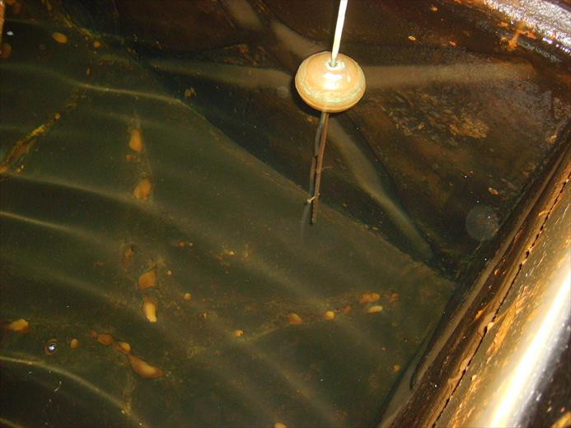
Comments: | LR: | 3 | GR: | 0
The main cisterns are old steel vessels that have been painted internally but are generally in poor order and need replacing.

Title: Main hospital cisterns - waterline
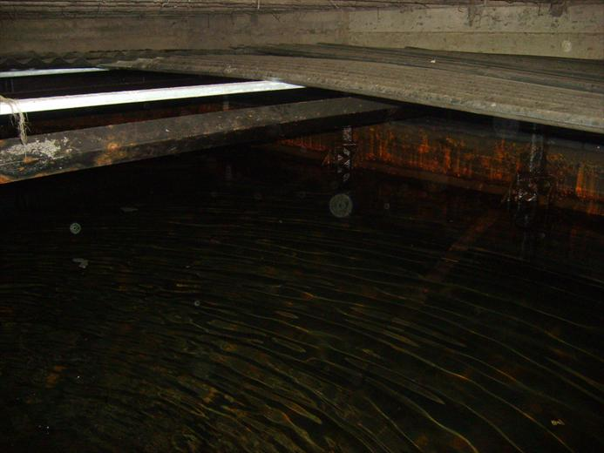
Comments: | LR: | 3 | GR: | 0
As can be seen the cisterns are not well enclosed or up to water bye law requirements.

Title: Main hospital cisterns
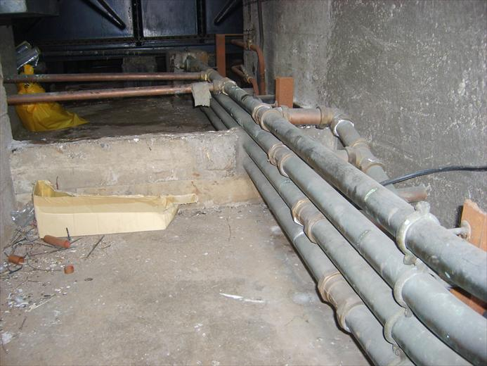
Comments: | LR: | 2 | GR: | 0
Primary cold water pipes are not insulated and the general area is in poor order.

Title: Main hospital rear cistern second supply
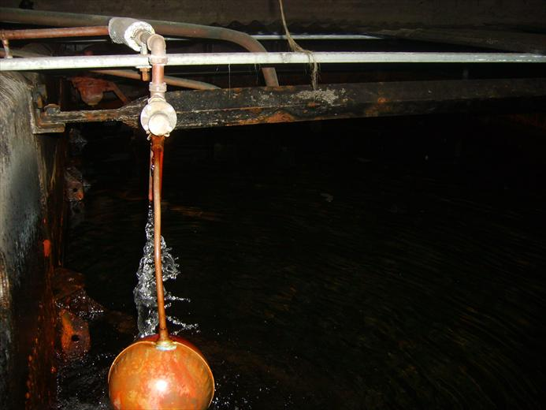
Comments: | LR: | 1 | GR: | 0
This second supply was working hard when we surveyed the site. It is not dosed with chlorine dioxide.

Title: Old building lead cistern
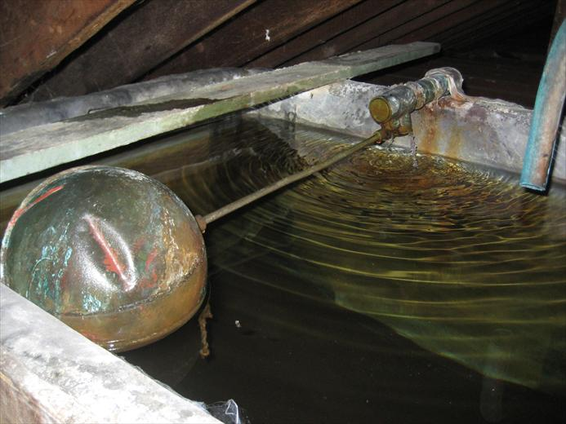
Comments: | LR: | 3 | GR: | 0
The old building has a few outlets served by an old wooden (lead lined) cistern that needs to be removed.

Title: Old building uninsulated water heater.
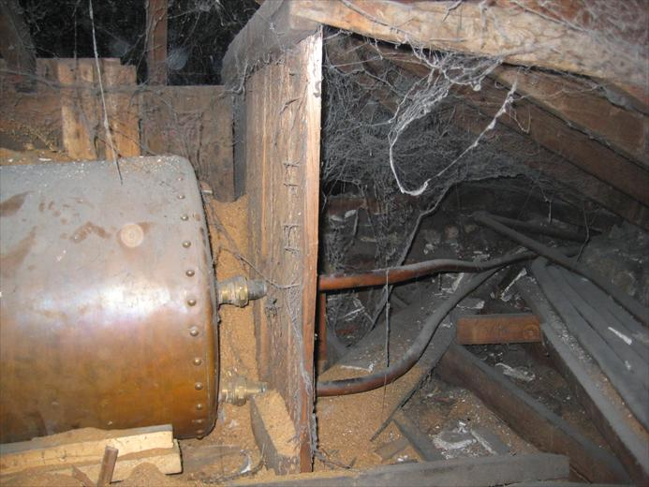
Comments: | LR: | 3 | GR: | 0
The old building has a few outlets served by an old uninsulated water heater running at very poor temperatures. We could not follow pipes for supply or feed but suspect this unit could be removed from service.

Title: Education cistern internal.
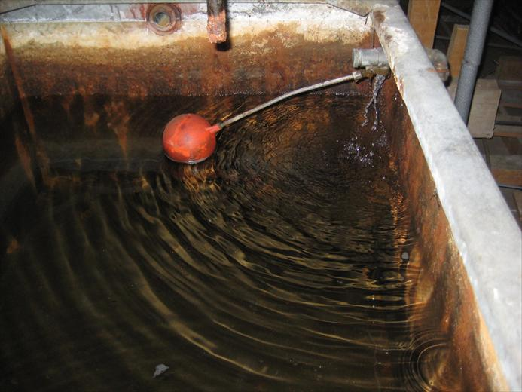
Comments: | LR: | 3 | GR: | 0
An old galvanised cistern in need of replacement.

Title: Education cistern primary heating returns.
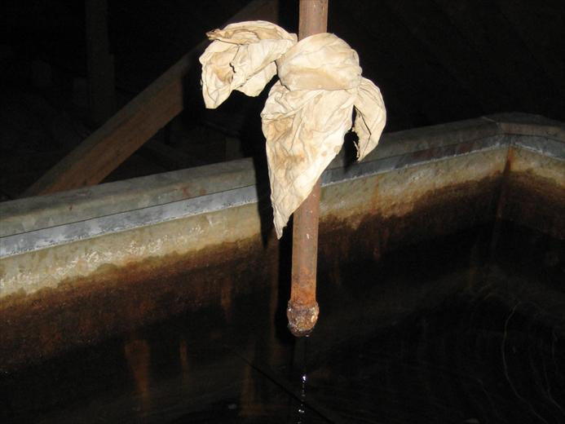
Comments: | LR: | 2 | GR: | 0
Primary heating should not vent back to CWDS and need redirecting.

Title: Unit 4, 5 and 6 cistern lid
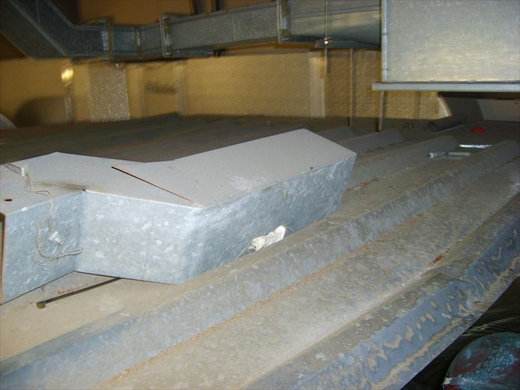
Comments: | LR: | 2 | GR: | 0
Unit 4, 5 and 6 cistern lid is not compliant and needs replacing.

Title: Unit 4, 5 and 6 cistern Internal
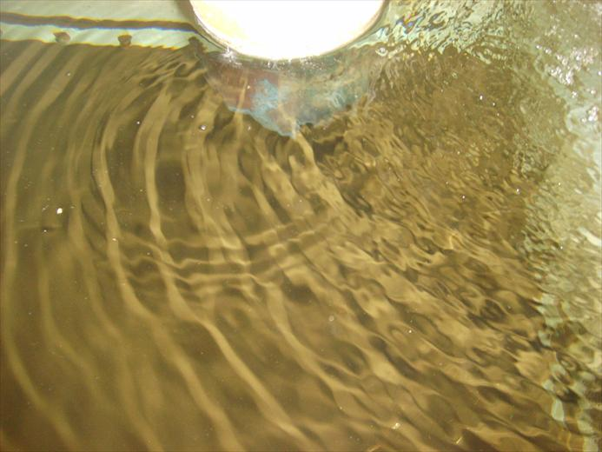
Comments: | LR: | 2 | GR: | 0
Unit 4, 5 and 6 cistern is a little grubby and needs to be cleaned and disinfected.

Title: Unit 7 and 8 cistern Internal
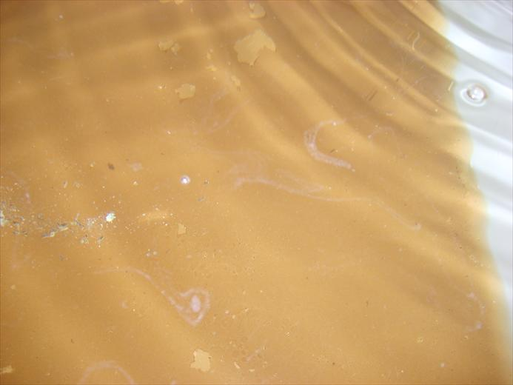
Comments: | LR: | 2 | GR: | 0
Unit 7 and 8 cistern is a little grubby and needs to be cleaned and disinfected.

Title: Facilities management cistern Internal
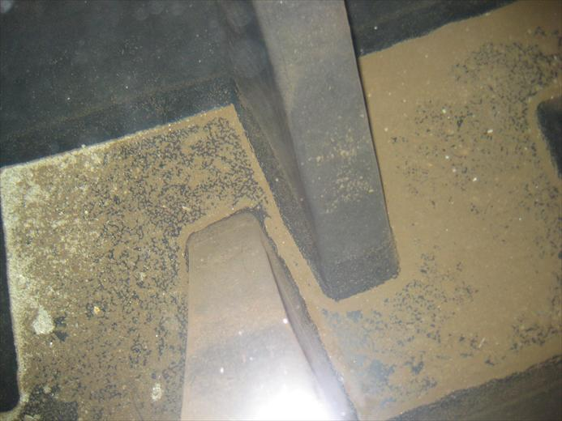
Comments: | LR: | 2 | GR: | 0
Facilities management cistern is a little grubby and needs to be cleaned and disinfected.

Title: Laboratory cistern Internal
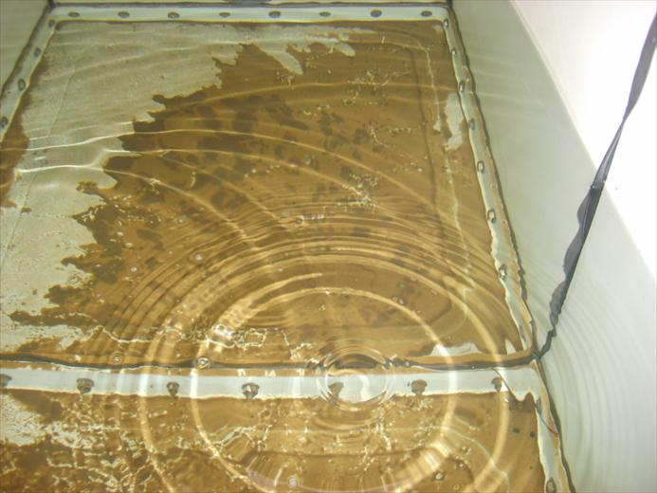
Comments: | LR: | 2 | GR: | 0
Laboratory cistern is a little grubby and needs to be cleaned and disinfected.

Title: Lodge cistern Internal
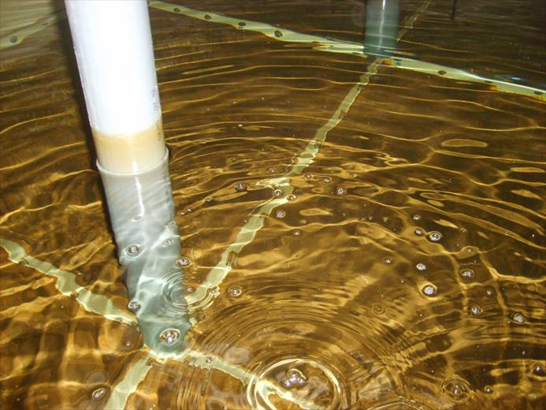
Comments: | LR: | 2 | GR: | 0
Lodge cistern is a little grubby and needs to be cleaned and disinfected.

Title: OPD instrument cistern Internal
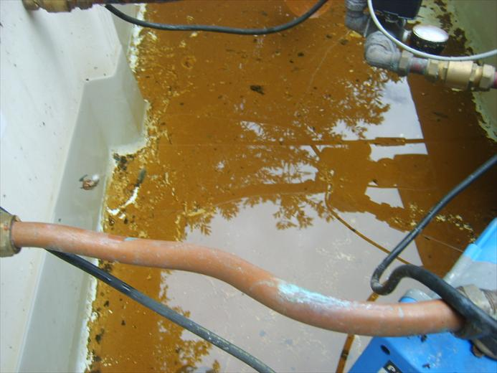
Comments: | LR: | 2 | GR: | 0
OPD instrument cistern is a little grubby and needs to be cleaned and disinfected.

Title: Example dead end on CWDS
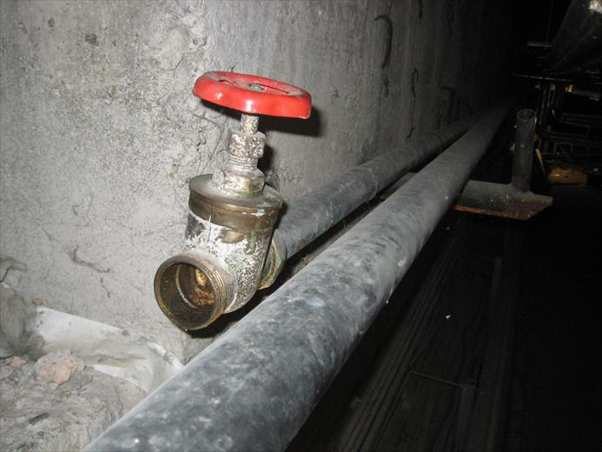
Comments: | LR: | 2 | GR: | 0
During our survey we could not trace all pipework from source to destination. We think this pipe heading to the water heaters may have been the old cold feed and that it is still linked to the main cisterns.

Title: Example dead end on HWS
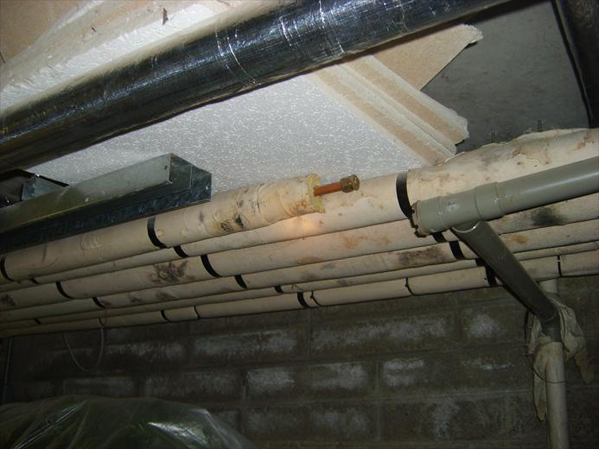
Comments: | LR: | 3 | GR: | 0
During our survey we could not trace all pipework from source to destination. The hot water service flow and return is not working under units 1 and 2. At the end of the HWS a closed valve was found.

Title: Example dead end on MWS
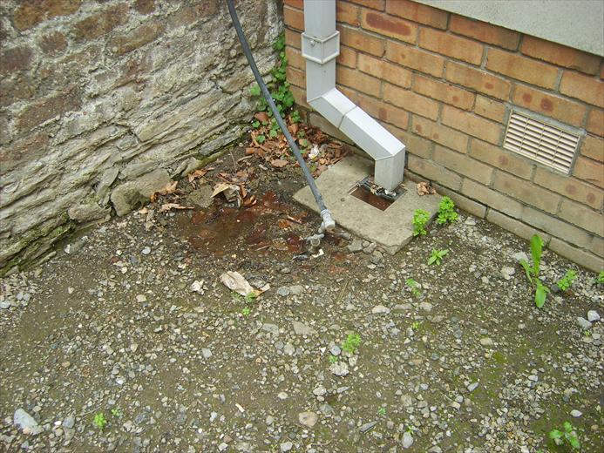
Comments: | LR: | 1 | GR: | 2
A mains water feed lying on the ground near the education building is both a dead leg and a back flow risk for the drinking water.

Assessment Finding's

Direct mains services (MCW) Survey - Mains water distribution
System ID: | 101
Survey Ref: | MCWS
Location: | Mains water distribution
Serving: | Feeds all other water services on site.
Risk Ratings |  | 4 | 3 |  | 2 | 1 |  | 0
Number of items that require attention - Legionella risks |  | 0 | 0 |  | 2 | 1 |  | 7
Number of items that require attention - General risks |  | 0 | 0 |  | 2 | 1 |  | 7
Questions not answered / Total number of questions |  | 1 | / |  | 11
Question |  |  |  | LR |  |  | GR
1, Are materials WRc compliant? |  |  |  | 2 |  |  | 2
Answer: No - old cast main above ground.
Recommendation: The large cast iron pipework and fittings should be replaced with those constructed of WRAS approved materials as improvements are made. The main is likely to be in poor condition and could have significant debris in low flow areas.
Question | LR | GR
3, Is distribution pipework insulated and does the system operate below 20°C? | 2 | 0
Answer: Cold water pipes are not well insulated.
Recommendation: As mains pipes are upgraded or refurbishment takes place better insulation should be fitted to the distribution system.
Question | LR | GR
8, Is the main protected against back flow (Wash down hoses, bib taps, Fire hoses Quick fill etc)? | 1 | 2
Answer: Lines like those found by Education are a concern.
Recommendation: Backflow is a real possibility with a pump directly fitted to the main supply. Connections such as those outside Education building area are a concern and should not be allowed. (See photo). Direct mains pumps are not generally allowed in the UK and are subject to approval by Dublin council in Ireland. Where possible a break tank should be used.
Question | LR | GR
10, Have identification labels been used? | 0 | 1
Answer: No - all outlets unlabelled.
Recommendation: Defined drinking water outlets need to be labelled so that they can be readily identified.

Cold Water Down Services (CWDS) Survey - All CWS distribution services.
System ID: | 201
Survey Ref: | CWDS
Location: | All CWS distribution services.
Serving: | All CWS distribution services.
Risk Ratings |  | 4 | 3 |  | 2 | 1 |  | 0
Number of items that require attention - Legionella risks |  | 0 | 1 |  | 3 | 1 |  | 4
Number of items that require attention - General risks |  | 0 | 0 |  | 0 | 1 |  | 8
Questions not answered / Total number of questions |  | 0 | / |  | 9
Question |  |  |  | LR |  |  | GR
6, Is the CWDS free from dead ends? |  |  |  | 3 |  |  | 0
Answer: No - significant dead legs found (Please see schematic drawing)
Recommendation: Dead legs identified on the schematics and the asset register should be removed.
Question | LR | GR
3, Is distribution pipework insulated and does the system operate below 20°C? | 2 | 0
Answer: No - Insulation is unsatisfactory.
Recommendation: Inadequate insulation needs to be replaced to meet the requirements of ACOP L8 as areas are improved.
Question | LR | GR
7, Are TMVs considered necessary and operating correctly? | 2 | 0
Answer: Yes - however flexible hoses noted.
Recommendation: Flexible hoses fitted after TMVs have recently shown to be a risk. Please see the enclosed document. The asset register has recorded areas where we noted flexible hoses. If these areas yield poor results the hoses should be considered as possible sources.
Question | LR | GR
8, Are all items fed by the CWDS in regular use (Wash down hoses, Emergency showers etc)? | 2 | 0
Answer: No - Fire hose reels fitted to the CWDS and / or MCW are not in regular use.
Recommendation: Install a double check valve suitable for fluid categories up to 3, Fluid which represents a slight health hazard because of substances of low toxicity on fire hose connections. Some assessments recommend flushing of fire hoses on a regular basis to avoid stagnation and dead legs. If this undertaken / possible aerosols must not be produced during flushing.
Question | LR | GR
9, Are all distribution valves labelled | 1 | 1
Answer: Zone isolating valves are not labelled.
Recommendation: All zone isolating valves need to be labelled so that they can be readily identified.

Cistern (Tank) Survey - Main hospital (front tank) T01
System ID: | 201
Survey Ref: | CWDS
Location: | Main hospital (front tank) T01
Serving: | All cold water to the main hospital building.
Risk Ratings |  | 4 | 3 |  | 2 | 1 |  | 0
Number of items that require attention - Legionella risks |  | 0 | 2 |  | 3 | 2 |  | 19
Number of items that require attention - General risks |  | 0 | 0 |  | 1 | 2 |  | 23
Questions not answered / Total number of questions |  | 0 | / |  | 26
Question |  |  |  | LR |  |  | GR
12, Internal condition of the cistern |  |  |  | 3 |  |  | 0
Answer: The water is clear and levels of debris are actually minimal as far as can be seen. However corrosion breakthrough is evident.
Recommendation: The cistern should be relined or replaced due to the significant levels of corrosion found. While many operational problems need to be over come with the number of faults present replacement of this cistern would provide the best long term cost effective action.
Question | LR | GR
19, Is the lid rigid, fixed and close fitting | 3 | 0
Answer: The lid is not made from approved materials and is not well enclosed.
Recommendation: A rigid close fitting lid should be fitted. In the hygiene world a gap of 1mm would be bigger than the mesh size of screens in modern GRP cisterns.
Question | LR | GR
15, Is a screened overflow pipe fitted | 2 | 0
Answer: No overflow screen installed
Recommendation: A suitably sized (and screened) overflow pipe should be fitted in accordance with Water Supply (Water Fitting) Regulations 1999.
Question | LR | GR
22, Is inlet pipework opposite to outlet pipework | 2 | 0
Answer: No - Fitted on adjacent (90 degrees) side.
Recommendation: During any replacement the inlet pipe needs to be repositioned to the end opposite to the outlet pipe.
Question | LR | GR
23, Is the cistern and local pipework insulated sufficiently to prevent heat gain or loss | 2 | 0
Answer: No - Nothing insulated.
Recommendation: The cistern and local distribution pipes need to be Insulated to maintain water temperatures recommended in ACOP L8.
Question | LR | GR
26, Are the valves and cistern labelled | 1 | 1
Answer: Valves and cistern are not labelled.
Recommendation: The cistern and main valves need to be labelled with an asset number to allow it to be clearly identified.
Question | LR | GR
20, Is the Lid fitted with screened vent | 1 | 0
Answer: No lid vent seen.
Recommendation: Any new lid needs to be fitted with a screened vent.
Question | LR | GR
21, Is the cistern lid fitted with a close fitting inspection hatch | 0 | 2
Answer: No inspection hatch fitted.
Recommendation: As the cistern is storing more than 1000 litres of water any new lid should be constructed so that the cistern may be inspected or cleansed without wholly uncovering the cistern. A tight fitting inspection hatch should be installed.
Question | LR | GR
4, Is access restricted above the cistern | 0 | 1
Answer: Slight head height restriction.
Recommendation: Storage cisterns should be so placed and equipped that the interior thereof can be inspected and cleansed and the float operated valve can be maintained. For this purpose a clear space of not less than 350 mm should be provided above the cistern. Headroom is just about acceptable but should not be reduced if cisterns are replaced.

Cistern (Tank) Survey - Main hospital (Rear tank) T02
System ID: | 201
Survey Ref: | CWDS
Location: | Main hospital (Rear tank) T02
Serving: | Cold water to the main hospital building and water heaters.
Risk Ratings |  | 4 | 3 |  | 2 | 1 |  | 0
Number of items that require attention - Legionella risks |  | 0 | 2 |  | 6 | 2 |  | 16
Number of items that require attention - General risks |  | 0 | 1 |  | 1 | 2 |  | 22
Questions not answered / Total number of questions |  | 0 | / |  | 26
Question |  |  |  | LR |  |  | GR
12, Internal condition of the cistern |  |  |  | 3 |  |  | 0
Answer: The water is clear and levels of debris are actually minimal as far as can be seen. However corrosion breakthrough is evident.
Recommendation: The cistern should be relined or replaced due to the significant levels of corrosion found. While many operational problems need to be over come with the number of faults present replacement of this cistern would provide the best long term cost effective action.
Question | LR | GR
19, Is the lid rigid, fixed and close fitting | 3 | 0
Answer: The lid is not made from approved materials and is not well enclosed.
Recommendation: A rigid close fitting lid should be fitted. In the hygiene world a gap of 1mm would be bigger than the mesh size of screens in modern GRP cisterns.
Question | LR | GR
15, Is a screened overflow pipe fitted | 2 | 0
Answer: No overflow screen installed
Recommendation: An overflow screen should be fitted with a screen mesh size of no greater than 0.65mm.
Question | LR | GR
17, Are potentially stagnant return pipes such as expansion pipes diverted | 2 | 0
Answer: HWS expansion pipe returns to the cistern (x3).
Recommendation: It is suggested that return pipes (3 No. HWS vents) are re-directed to a tun dish and drain.
Question | LR | GR
22, Is inlet pipework opposite to outlet pipework | 2 | 0
Answer: No - Fitted on adjacent (90 degrees) side.
Recommendation: During any replacement the inlet pipe needs to be repositioned to the end opposite to the outlet pipe.
Question | LR | GR
23, Is the cistern and local pipework insulated sufficiently to prevent heat gain or loss | 2 | 0
Answer: No - Nothing insulated.
Recommendation: The cistern and local distribution pipes need to be Insulated to maintain water temperatures recommended in ACOP L8.
Question | LR | GR
24, Is the tank room free from dead ends. | 2 | 0
Answer: The 4 inch supply to this tank is not required.
Recommendation: The 4 inch cast supply to the rear cistern is not running and therefore not required and should be cut back as close as possible to the front cistern supply. It is currently acting as a dead leg.
Question | LR | GR
25, Are there any secondary make ups to the cistern | 2 | 0
Answer: Yes - Second float valve (Mains fed operating during survey).
Recommendation: A second cold water main has been installed. The old 4 inch cast main is not operating. The water passing through the new main is not getting dosed with Chlorine Dioxide. (See tank room sketch)
Question | LR | GR
26, Are the valves and cistern labelled | 1 | 1
Answer: Valves and cistern are not labelled.
Recommendation: The cistern and main valves need to be labelled with an asset number to allow it to be clearly identified.
Question | LR | GR
20, Is the Lid fitted with screened vent | 1 | 0
Answer: No lid vent seen.
Recommendation: Any new lid needs to be fitted with a screened vent.
Question | LR | GR
7, Is the cistern linked to another | 0 | 3
Answer: Yes - In parallel (via header). HWS from rear cistern only.
Recommendation: Health Technical Memorandum 04-01-A Paragraph 7.26 states, Depending on size and/or capacity, tankage should be divided into convenient compartments suitably interconnected and valved to facilitate cleaning, disinfection, repair, modification and inspection, without seriously disturbing the cold water service. HWS feed has been installed so as to only be fed from the rear cistern, this should be modified during any cistern replacement works.
Question | LR | GR
21, Is the cistern lid fitted with a close fitting inspection hatch | 0 | 2
Answer: No inspection hatch fitted.
Recommendation: As the cistern is storing more than 1000 litres of water any new lid should be constructed so that the cistern may be inspected or cleansed without wholly uncovering the cistern. A tight fitting inspection hatch should be installed.
Question | LR | GR
4, Is access restricted above the cistern | 0 | 1
Answer: Slight head height restriction.
Recommendation: Storage cisterns should be so placed and equipped that the interior thereof can be inspected and cleansed and the float operated valve can be maintained. For this purpose a clear space of not less than 350 mm should be provided above the cistern. Headroom is just about acceptable but should not be reduced if cisterns are replaced.

Cistern (Tank) Survey - Dirty utility cistern T03
System ID: | 202
Survey Ref: | CWDS
Location: | Dirty utility cistern T03
Serving: | Sluice sink cold flush water.
Risk Ratings |  | 4 | 3 |  | 2 | 1 |  | 0
Number of items that require attention - Legionella risks |  | 0 | 0 |  | 5 | 2 |  | 19
Number of items that require attention - General risks |  | 0 | 0 |  | 3 | 1 |  | 22
Questions not answered / Total number of questions |  | 0 | / |  | 26
Question |  |  |  | LR |  |  | GR
6, Is the cistern redundant, stagnant or over-sized |  |  |  | 2 |  |  | 0
Answer: Water turnover estimated at greater than 24 hours.
Recommendation: The cistern appears over sized. Water turnover needs to be established and if not adequate steps taken to reduce storage or improve turnover possibly by reducing the operating level.
Question | LR | GR
12, Internal condition of the cistern | 2 | 0
Answer: The stored water is clear, however the cistern has significant debris on horizontal areas.
Recommendation: The cistern needs to be cleaned and disinfected in accordance with ACOP L8.
Question | LR | GR
15, Is a screened overflow pipe fitted | 2 | 0
Answer: No overflow screen installed
Recommendation: An overflow screen should be fitted with a screen mesh size of no greater than 0.65mm.
Question | LR | GR
22, Is inlet pipework opposite to outlet pipework | 2 | 0
Answer: No - Outlet fitted on the same side as the inlet pipe.
Recommendation: The inlet pipe needs to be repositioned to the end opposite to the outlet pipe.
Question | LR | GR
23, Is the cistern and local pipework insulated sufficiently to prevent heat gain or loss | 2 | 0
Answer: No - Cistern not insulated, but local pipework is insulated.
Recommendation: The cistern needs to be Insulated to maintain water temperatures recommended in ACOP L8.
Question | LR | GR
26, Are the valves and cistern labelled | 1 | 1
Answer: Valves and cistern are not labelled.
Recommendation: The cistern and main valves need to be labelled with an asset number to allow it to be clearly identified.
Question | LR | GR
20, Is the Lid fitted with screened vent | 1 | 0
Answer: No lid vent seen.
Recommendation: The existing lid vent needs to be fitted with a screen.
Question | LR | GR
8, What is supply water temperature at cistern inlet | 0 | 2
Answer: Unable to test flooded.
Recommendation: The float valve is letting past and the cistern is over flowing lightly.
Question | LR | GR
16, Is a screened warning overflow pipe fitted. | 0 | 2
Answer: The main overflow does not act as a warning.
Recommendation: A suitably sized (and screened) warning overflow pipe should be fitted in accordance with Water Supply (Water Fitting) Regulations 1999. The existing overflow goes straight to drain.
Question | LR | GR
21, Is the cistern lid fitted with a close fitting inspection hatch | 0 | 2
Answer: No inspection hatch fitted.
Recommendation: As the cistern is storing more than 1000 litres of water the lid should be constructed so that the cistern may be inspected or cleansed without wholly uncovering the cistern. A tight fitting inspection hatch should be installed.

Cistern (Tank) Survey - Old house area T04
System ID: | 203
Survey Ref: | CWDS
Location: | Old house area T04
Serving: | Parts of old house building only.
Risk Ratings |  | 4 | 3 |  | 2 | 1 |  | 0
Number of items that require attention - Legionella risks |  | 0 | 2 |  | 0 | 0 |  | 2
Number of items that require attention - General risks |  | 0 | 0 |  | 0 | 0 |  | 4
Questions not answered / Total number of questions |  | 22 | / |  | 26
Question |  |  |  | LR |  |  | GR
2, Construction of the cistern |  |  |  | 3 |  |  | 0
Answer: Handmade wooden frame with lead linner.
Recommendation: This old lead cistern with no lid should be isolated avoiding the production of dead ends and removed from service.
Question | LR | GR
6, Is the cistern redundant, stagnant or over-sized | 3 | 0
Answer: Yes - Oversized.
Recommendation: Disconnect and remove the cistern together with any redundant pipework and water services. The services fed can be supplied by the main cisterns.

Cistern (Tank) Survey - Ground level rear of OPD T05
System ID: | 204
Survey Ref: | CWDS (Boosted)
Location: | Ground level rear of OPD T05
Serving: | CWS to pure water unit for instrument washing.
Risk Ratings |  | 4 | 3 |  | 2 | 1 |  | 0
Number of items that require attention - Legionella risks |  | 0 | 0 |  | 1 | 3 |  | 22
Number of items that require attention - General risks |  | 0 | 0 |  | 1 | 1 |  | 24
Questions not answered / Total number of questions |  | 0 | / |  | 26
Question |  |  |  | LR |  |  | GR
12, Internal condition of the cistern |  |  |  | 2 |  |  | 0
Answer: The stored water is clear, however the cistern has significant debris on horizontal areas.
Recommendation: The cistern needs to be cleaned and disinfected in accordance with ACOP L8.
Question | LR | GR
26, Are the valves and cistern labelled | 1 | 1
Answer: Cistern is not labelled.
Recommendation: The cistern needs to be labelled with an asset number to allow it to be clearly identified.
Question | LR | GR
5, Describe the external structural condition of the cistern | 1 | 0
Answer: In good condition.
Recommendation: Due to the external location the cistern is externally rether dirty. A clean would reduce the risk of debris entering the cistern during inspections.
Question | LR | GR
6, Is the cistern redundant, stagnant or over-sized | 1 | 0
Answer: Water turnover estimated at greater than 24 hours.
Recommendation: The cistern appears over sized. Water turnover is likely to be variable based on demand. If possible confirm that the cistern will always be used at least weekly.
Question | LR | GR
15, Is a screened overflow pipe fitted | 0 | 2
Answer: No overflow pipe fitted
Recommendation: A suitably sized (and screened) overflow pipe should be fitted in accordance with Water Supply (Water Fitting) Regulations 1999. Holes in the cistern need to be screened or plugged.

Cistern (Tank) Survey - Education building T06
System ID: | 205
Survey Ref: | CWDS
Location: | Education building T06
Serving: | Education building only.
Risk Ratings |  | 4 | 3 |  | 2 | 1 |  | 0
Number of items that require attention - Legionella risks |  | 0 | 4 |  | 4 | 2 |  | 15
Number of items that require attention - General risks |  | 0 | 0 |  | 1 | 1 |  | 23
Questions not answered / Total number of questions |  | 1 | / |  | 26
Question |  |  |  | LR |  |  | GR
17, Are potentially stagnant return pipes such as expansion pipes diverted |  |  |  | 3 |  |  | 2
Answer: Primary heating expansion pipe returns to the cistern.
Recommendation: Heating system vent pipes need to be re-directed to a suitable receiver. Some evidence of one valve letting past to the cold water system.
Question | LR | GR
6, Is the cistern redundant, stagnant or over-sized | 3 | 0
Answer: Yes - Oversized.
Recommendation: The cistern appears over sized. Water turnover needs to be established and if not adequate steps taken to reduce storage or improve turnover.
Question | LR | GR
12, Internal condition of the cistern | 3 | 0
Answer: The stored water is clear, however the cistern is corroded with significant debris on horizontal areas.
Recommendation: The cistern needs to be replaced with a new water reg compliant cistern incorporating all other recommendations made here.
Question | LR | GR
19, Is the lid rigid, fixed and close fitting | 3 | 0
Answer: No lid is fitted.
Recommendation: A rigid close fitting lid should be fitted.
Question | LR | GR
9, What is the stored water temperature in the cistern | 2 | 0
Answer: Cistern temperature (>20°C) 21°C.
Recommendation:
Question | LR | GR
15, Is a screened overflow pipe fitted | 2 | 0
Answer: No overflow screen installed
Recommendation: An overflow screen should be fitted with a screen mesh size of no greater than 0.65mm.
Question | LR | GR
22, Is inlet pipework opposite to outlet pipework | 2 | 0
Answer: No - Outlet fitted on the same side as the inlet pipe.
Recommendation: The inlet pipe needs to be repositioned to the end opposite to the outlet pipe.
Question | LR | GR
23, Is the cistern and local pipework insulated sufficiently to prevent heat gain or loss | 2 | 0
Answer: No - Cistern not insulated, but local pipework is insulated.
Recommendation: The cistern needs to be Insulated to maintain water temperatures recommended in ACOP L8.
Question | LR | GR
26, Are the valves and cistern labelled | 1 | 1
Answer: Valves and cistern are not labelled.
Recommendation: The cistern and main valves need to be labelled with an asset number to allow it to be clearly identified.
Question | LR | GR
20, Is the Lid fitted with screened vent | 1 | 0
Answer: No lid vent seen.
Recommendation: The lid needs to be fitted with a screened vent.

Cistern (Tank) Survey - First floor plant room 456 T07
System ID: | 206
Survey Ref: | CWDS
Location: | First floor plant room 456 T07
Serving: | All CWDS to the 456 extensions including HWS.
Risk Ratings |  | 4 | 3 |  | 2 | 1 |  | 0
Number of items that require attention - Legionella risks |  | 0 | 2 |  | 4 | 2 |  | 18
Number of items that require attention - General risks |  | 0 | 0 |  | 1 | 1 |  | 24
Questions not answered / Total number of questions |  | 0 | / |  | 26
Question |  |  |  | LR |  |  | GR
6, Is the cistern redundant, stagnant or over-sized |  |  |  | 3 |  |  | 0
Answer: Water turnover estimated at greater than 24 hours.
Recommendation: The total stored capacity appears to be over sized. Water turnover needs to be established and steps taken to improve turnover within this cistern.
Question | LR | GR
19, Is the lid rigid, fixed and close fitting | 3 | 0
Answer: The cistern lid is not close fitting around the edges or at joins.
Recommendation: The existing lid needs to be replaced with a rigid close fitting lid.
Question | LR | GR
12, Internal condition of the cistern | 2 | 0
Answer: The stored water is clear, however the cistern has significant debris on horizontal areas.
Recommendation: The cistern needs to be cleaned and disinfected in accordance with ACOP L8.
Question | LR | GR
15, Is a screened overflow pipe fitted | 2 | 0
Answer: No overflow screen installed
Recommendation: An overflow screen should be fitted with a screen mesh size of no greater than 0.65mm.
Question | LR | GR
17, Are potentially stagnant return pipes such as expansion pipes diverted | 2 | 0
Answer: HWS expansion pipe returns to the cistern.
Recommendation: The vent pipe from the calorifier should be moved so if discharge occurs the water goes to a tundish. Any damaged areas of the cistern lid should be repaired so that the cistern remains enclosed after the return pipe has been re-directed.
Question | LR | GR
22, Is inlet pipework opposite to outlet pipework | 2 | 0
Answer: No - Outlet fitted on the same side as the inlet pipe.
Recommendation: The inlet pipe needs to be repositioned to the end opposite to the outlet pipe.
Question | LR | GR
26, Are the valves and cistern labelled | 1 | 1
Answer: Cistern is not labelled.
Recommendation: The cistern needs to be labelled with an asset number to allow it to be clearly identified.
Question | LR | GR
20, Is the Lid fitted with screened vent | 1 | 0
Answer: No lid vent seen.
Recommendation: The lid needs to be fitted with a screened vent.
Question | LR | GR
21, Is the cistern lid fitted with a close fitting inspection hatch | 0 | 2
Answer: No inspection hatch fitted.
Recommendation: As the cistern is storing more than 1000 litres of water the lid should be constructed so that the cistern may be inspected or cleansed without wholly uncovering the cistern. A tight fitting inspection hatch should be installed.

Cistern (Tank) Survey - Ground level rear of units 7&8 T08
System ID: | 207
Survey Ref: | CWDS (Boosted)
Location: | Ground level rear of units 7&8 T08
Serving: | All CWDS to unit 7&8 extension including HWS.
Risk Ratings |  | 4 | 3 |  | 2 | 1 |  | 0
Number of items that require attention - Legionella risks |  | 0 | 1 |  | 1 | 2 |  | 22
Number of items that require attention - General risks |  | 0 | 0 |  | 0 | 1 |  | 25
Questions not answered / Total number of questions |  | 0 | / |  | 26
Question |  |  |  | LR |  |  | GR
6, Is the cistern redundant, stagnant or over-sized |  |  |  | 3 |  |  | 0
Answer: Water turnover estimated at greater than 24 hours.
Recommendation: The cistern appears over sized. Water turnover needs to be established and if not adequate steps taken to reduce storage or improve turnover.
Question | LR | GR
12, Internal condition of the cistern | 2 | 0
Answer: The stored water is clear, however the cistern has significant debris on horizontal areas.
Recommendation: The cistern needs to be cleaned and disinfected in accordance with ACOP L8.
Question | LR | GR
26, Are the valves and cistern labelled | 1 | 1
Answer: Cistern is not labelled.
Recommendation: The cistern needs to be labelled with an asset number to allow it to be clearly identified.
Question | LR | GR
5, Describe the external structural condition of the cistern | 1 | 0
Answer: In good condition.
Recommendation: Due to the external location the cistern is externally rether dirty. A clean would reduce the risk of debris entering the cistern during inspections.

Cistern (Tank) Survey - Facilities management T09
System ID: | 208
Survey Ref: | CWDS
Location: | Facilities management T09
Serving: | Facilities management building only.
Risk Ratings |  | 4 | 3 |  | 2 | 1 |  | 0
Number of items that require attention - Legionella risks |  | 0 | 1 |  | 4 | 3 |  | 18
Number of items that require attention - General risks |  | 0 | 0 |  | 1 | 1 |  | 24
Questions not answered / Total number of questions |  | 0 | / |  | 26
Question |  |  |  | LR |  |  | GR
19, Is the lid rigid, fixed and close fitting |  |  |  | 3 |  |  | 0
Answer: No lid is fitted.
Recommendation: A rigid close fitting lid should be fitted.
Question | LR | GR
12, Internal condition of the cistern | 2 | 0
Answer: The stored water is clear, however the cistern has moderate debris on horizontal areas.
Recommendation: The cistern needs to be cleaned and disinfected in accordance with ACOP L8.
Question | LR | GR
15, Is a screened overflow pipe fitted | 2 | 0
Answer: No overflow screen installed
Recommendation: An overflow screen should be fitted with a screen mesh size of no greater than 0.65mm.
Question | LR | GR
17, Are potentially stagnant return pipes such as expansion pipes diverted | 2 | 0
Answer: HWS expansion pipe returns to the cistern.
Recommendation: It is suggested that hot water expansion pipes are re-directed to a tun dish.
Question | LR | GR
23, Is the cistern and local pipework insulated sufficiently to prevent heat gain or loss | 2 | 0
Answer: No - Nothing insulated.
Recommendation: The cistern and local pipes need to be Insulated to maintain water temperatures recommended in ACOP L8.
Question | LR | GR
14, Are there isolating valves on the cistern inlet and outlets | 1 | 2
Answer: No inlet valve fitted.
Recommendation: Install an isolating valve on the cistern inlet to allow isolation and maintenance.
Question | LR | GR
26, Are the valves and cistern labelled | 1 | 1
Answer: Valves and cistern are not labelled.
Recommendation: The cistern and main valves need to be labelled with an asset number to allow it to be clearly identified.
Question | LR | GR
20, Is the Lid fitted with screened vent | 1 | 0
Answer: No lid vent seen.
Recommendation: The lid needs to be fitted with a screened vent.

Cistern (Tank) Survey - Ground level rear of laboratory T10
System ID: | 209
Survey Ref: | CWDS (Boosted)
Location: | Ground level rear of laboratory T10
Serving: | All CWDS to the lab building including HWS.
Risk Ratings |  | 4 | 3 |  | 2 | 1 |  | 0
Number of items that require attention - Legionella risks |  | 0 | 0 |  | 1 | 3 |  | 22
Number of items that require attention - General risks |  | 0 | 0 |  | 0 | 2 |  | 24
Questions not answered / Total number of questions |  | 0 | / |  | 26
Question |  |  |  | LR |  |  | GR
12, Internal condition of the cistern |  |  |  | 2 |  |  | 0
Answer: The stored water is clear, however the cistern has significant debris on horizontal areas.
Recommendation: The cistern needs to be cleaned and disinfected in accordance with ACOP L8.
Question | LR | GR
18, Cistern fitted with drain valve | 1 | 1
Answer: No drain valve fitted.
Recommendation: A suitable drain valve should be fitted to facilitate complete draining of the cistern. This needs to be carried out without creating a dead leg area that may result in bacterial build up.
Question | LR | GR
26, Are the valves and cistern labelled | 1 | 1
Answer: Valves and cistern are not labelled.
Recommendation: The cistern and main valves need to be labelled with an asset number to allow it to be clearly identified.
Question | LR | GR
5, Describe the external structural condition of the cistern | 1 | 0
Answer: In good condition but dirty.
Recommendation: Due to the external location the cistern is externally rether dirty. A clean would reduce the risk of debris entering the cistern during inspections.

Cistern (Tank) Survey - Lodge roof top T11A and B
System ID: | 210
Survey Ref: | CWDS
Location: | Lodge roof top T11A and B
Serving: | All CWDS to the lodge building including HWS.
Risk Ratings |  | 4 | 3 |  | 2 | 1 |  | 0
Number of items that require attention - Legionella risks |  | 0 | 0 |  | 3 | 3 |  | 20
Number of items that require attention - General risks |  | 0 | 0 |  | 0 | 2 |  | 24
Questions not answered / Total number of questions |  | 0 | / |  | 26
Question |  |  |  | LR |  |  | GR
6, Is the cistern redundant, stagnant or over-sized |  |  |  | 2 |  |  | 0
Answer: Water turnover estimated at greater than 24 hours.
Recommendation: Water turnover could present an issue if the lodge is under occupied. Water meter readings allow turnover to be monitored. Usage much below 11m3 per day would indicate over capacity.
Question | LR | GR
12, Internal condition of the cistern | 2 | 0
Answer: The stored water is clear, however the cistern has significant debris on horizontal areas.
Recommendation: The cistern needs to be cleaned and disinfected in accordance with ACOP L8.
Question | LR | GR
24, Is the tank room free from dead ends. | 2 | 0
Answer: No
Recommendation: Minor dead legs created by isolated outlet valves. The closed valves should be opened to allow flow at all times.
Question | LR | GR
18, Cistern fitted with drain valve | 1 | 1
Answer: No drain valve fitted.
Recommendation: A suitable drain valve should be fitted to facilitate complete draining of the cistern. This needs to be carried out without creating a dead leg area that may result in bacterial build up.
Question | LR | GR
26, Are the valves and cistern labelled | 1 | 1
Answer: Valves and cistern are not labelled.
Recommendation: The cistern and main valves need to be labelled with an asset number to allow it to be clearly identified.
Question | LR | GR
7, Is the cistern linked to another | 1 | 0
Answer: Yes - In parallel (2 in total)
Recommendation: Multiple linked storage tanks should be avoided because of operational difficulties in preventing unequal flow rates and possible stagnation. The outlet arrangement on these cisterns appears to help balanced turnover but unequal flow should be watched for.

Hot Water Down Services (HWS) Survey - HWS Outlets and system
System ID: | 301
Survey Ref: | HWS
Location: | HWS Outlets and system
Serving: | All HWS in the building
Risk Ratings |  | 4 | 3 |  | 2 | 1 |  | 0
Number of items that require attention - Legionella risks |  | 0 | 2 |  | 0 | 1 |  | 6
Number of items that require attention - General risks |  | 0 | 0 |  | 0 | 1 |  | 8
Questions not answered / Total number of questions |  | 0 | / |  | 9
Question |  |  |  | LR |  |  | GR
3, Do all parts of the distribution system operate above 50°C? |  |  |  | 3 |  |  | 0
Answer: No - Lowest temperature <50°C at 1 minute.
Recommendation: Increasing the stored hot water temperature will resolve the issue of low outlet temperatures. Scalding is always a knock on risk but outlet temperatures are critical for control.
Question | LR | GR
5, Is the HWS free from dead ends? | 3 | 0
Answer: No
Recommendation: Dead legs should be removed as identified on our schematic drawings. The flow and return circuit is not operating and has created large dead legs under units 1 and 2. The end of the line has been capped, this requires attention.
Question | LR | GR
9, Are all distribution valves labelled? | 1 | 1
Answer: No zone isolating valves labelled
Recommendation: Zone isolating valves should be labelled so that they can be readily identified.

Plate Heat Exchanger Survey - Main Hospital Cal01 & 02
System ID: | 301
Survey Ref: | HWS
Location: | Main Hospital Cal01 & 02
Serving: | The main hot water supply to wards and main building.
Risk Ratings |  | 4 | 3 |  | 2 | 1 |  | 0
Number of items that require attention - Legionella risks |  | 0 | 2 |  | 1 | 1 |  | 15
Number of items that require attention - General risks |  | 0 | 0 |  | 0 | 1 |  | 18
Questions not answered / Total number of questions |  | 1 | / |  | 20
Question |  |  |  | LR |  |  | GR
11, What is the outlet temperature of the water heater? |  |  |  | 3 |  |  | 0
Answer: Temperature 51°C (surface measurement)
Recommendation: If temperature is used as a means of control, each vessel should deliver water at a temperature of at least 60°C (ACoP L8 Para 152). Please see additional comments supplied.
Question | LR | GR
14, Do all parts of the system operate at target temperatures at least once every day? | 3 | 0
Answer: No
Recommendation: Surprisingly the base of the buffer vessels was found to be cold. Please see additional comments supplied.
Question | LR | GR
7, If known what is the Internal condition of the buffer vessel? | 2 | 0
Answer: The internal condition is unknown as the unit has not been opened for some time.
Recommendation: Introduce an annual internal inspection and maintenance plan. This could be achieved through the old bundle access holes. If conditions are satisfactory the inspection period could be reduced.
Question | LR | GR
19, Is the water heater and associated plant labelled? | 1 | 1
Answer: No
Recommendation: The water heater should be labelled with Asset Number so that it can be clearly identified.

Calorifier (Water heater) Survey - Old house area Cal03
System ID: | 302
Survey Ref: | HWS
Location: | Old house area Cal03
Serving: | Old house area only limits unknown.
Risk Ratings |  | 4 | 3 |  | 2 | 1 |  | 0
Number of items that require attention - Legionella risks |  | 0 | 2 |  | 0 | 0 |  | 8
Number of items that require attention - General risks |  | 0 | 0 |  | 1 | 1 |  | 8
Questions not answered / Total number of questions |  | 15 | / |  | 25
Question |  |  |  | LR |  |  | GR
4, Is the water heater required |  |  |  | 3 |  |  | 0
Answer: No
Recommendation: Remove the water heater and connect any served outlets to the main HWS running close to the same locations.
Question | LR | GR
15, What is the outlet temperature of the water heater | 3 | 0
Answer: Poor Temperature 42°C
Recommendation: If the unit fed patient areas we would have issued a risk rating of 4. Unit should not remain working at this temperature.
Question | LR | GR
8, Describe the external condition of the water heater | 0 | 2
Answer: Uninsulated
Recommendation: The water heater is surrounded with wood chippings but essentially uninsulated.
Question | LR | GR
3, Is safe access provided to the area around the water heater | 0 | 1
Answer: No - Access considered unsafe.
Recommendation: The attic area does not provide a safe working platform to the water heater.

Calorifier (Water heater) Survey - Units 4 - 5 & 6 1st floor Plant room CAL04
System ID: | 303
Survey Ref: | HWS
Location: | Units 4 - 5 & 6 1st floor Plant room CAL04
Serving: | Units 4 - 5 & 6 HWS only.
Risk Ratings |  | 4 | 3 |  | 2 | 1 |  | 0
Number of items that require attention - Legionella risks |  | 0 | 1 |  | 2 | 2 |  | 20
Number of items that require attention - General risks |  | 0 | 0 |  | 0 | 2 |  | 23
Questions not answered / Total number of questions |  | 0 | / |  | 25
Question |  |  |  | LR |  |  | GR
14, Will temperatures reach target throughout the vessel for at least 1 hour daily. |  |  |  | 3 |  |  | 0
Answer: No - Base of vessel cool.
Recommendation: The water temperature at the base of the water heater is much cooler than the water temperature at the top. A shunt pump to move hot water from the top of the calorifier to the base should be fitted.
Question | LR | GR
6, Is the water heater fitted with an inspection hatch | 2 | 0
Answer: No inspection hatch has been fitted.
Recommendation: As an inspection hatch has not been fitted, any debris in the water at the base of the calorifier should be purged to a suitable drain on an annual basis.
Question | LR | GR
12, Is the water heater fitted with a drain valve in the base of the unit | 2 | 0
Answer: No, but the drain valve may be located under the insulation.
Recommendation: If a drain valve is fitted the insulation should be cut back to allow access to it.
Question | LR | GR
17, Are Temperature Gauges/Thermometer pockets fitted to the Flow, Return and base of the water heater | 1 | 1
Answer: No thermometer or immersion pockets fitted on the return to the water heater.
Recommendation: Fit thermometer pockets or temperature gauges on the secondary return to the water heater.
Question | LR | GR
21, Is the water heater and associated plant labelled | 1 | 1
Answer: No
Recommendation: The water heater should be labelled with Asset Number so that it can be clearly identified.

Calorifier (Water heater) Survey - Units 7&8 Rear Plant room CAL05
System ID: | 304
Survey Ref: | HWS
Location: | Units 7&8 Rear Plant room CAL05
Serving: | Units 7 & 8 HWS only.
Risk Ratings |  | 4 | 3 |  | 2 | 1 |  | 0
Number of items that require attention - Legionella risks |  | 0 | 0 |  | 0 | 2 |  | 23
Number of items that require attention - General risks |  | 0 | 0 |  | 0 | 2 |  | 23
Questions not answered / Total number of questions |  | 0 | / |  | 25
Question |  |  |  | LR |  |  | GR
17, Are Temperature Gauges/Thermometer pockets fitted to the Flow, Return and base of the water heater |  |  |  | 1 |  |  | 1
Answer: No thermometer or immersion pockets fitted on the return to the water heater.
Recommendation: Fit thermometer pockets or temperature gauges on the secondary return to the water heater.
Question | LR | GR
21, Is the water heater and associated plant labelled | 1 | 1
Answer: No
Recommendation: The water heater should be labelled with Asset Number so that it can be clearly identified.

Calorifier (Water heater) Survey - Facilities management Cal06
System ID: | 305
Survey Ref: | HWS
Location: | Facilities management Cal06
Serving: | Facilities management building only.
Risk Ratings |  | 4 | 3 |  | 2 | 1 |  | 0
Number of items that require attention - Legionella risks |  | 0 | 0 |  | 2 | 2 |  | 21
Number of items that require attention - General risks |  | 0 | 0 |  | 1 | 2 |  | 22
Questions not answered / Total number of questions |  | 0 | / |  | 25
Question |  |  |  | LR |  |  | GR
6, Is the water heater fitted with an inspection hatch |  |  |  | 2 |  |  | 0
Answer: No inspection hatch has been fitted.
Recommendation: As an inspection hatch has not been fitted, any debris in the water at the base of the calorifier should be purged to a suitable drain on an annual basis.
Question | LR | GR
12, Is the water heater fitted with a drain valve in the base of the unit | 2 | 0
Answer: No
Recommendation: A suitable drain valve should be fitted to facilitate complete drainage and flushing of the water heater.
Question | LR | GR
17, Are Temperature Gauges/Thermometer pockets fitted to the Flow, Return and base of the water heater | 1 | 1
Answer: No thermometer or immersion pockets fitted.
Recommendation: Fit thermometer pockets or temperature gauges on the water heater.
Question | LR | GR
21, Is the water heater and associated plant labelled | 1 | 1
Answer: No
Recommendation: The water heater should be labelled with Asset Number so that it can be clearly identified.
Question | LR | GR
15, What is the outlet temperature of the water heater | 0 | 2
Answer: Temperature >66°C
Recommendation: The thermostat setting should be adjusted as the water heater is operating slightly above target temperatures. This may cause a scalding risk.

Calorifier (Water heater) Survey - Laboratory Cal07
System ID: | 306
Survey Ref: | HWS (Boosted)
Location: | Laboratory Cal07
Serving: | Laboratory building only.
Risk Ratings |  | 4 | 3 |  | 2 | 1 |  | 0
Number of items that require attention - Legionella risks |  | 0 | 0 |  | 1 | 2 |  | 22
Number of items that require attention - General risks |  | 0 | 0 |  | 0 | 2 |  | 23
Questions not answered / Total number of questions |  | 0 | / |  | 25
Question |  |  |  | LR |  |  | GR
6, Is the water heater fitted with an inspection hatch |  |  |  | 2 |  |  | 0
Answer: No inspection hatch has been fitted.
Recommendation: As an inspection hatch has not been fitted, any debris in the water at the base of the calorifier should be purged to a suitable drain on an annual basis.
Question | LR | GR
17, Are Temperature Gauges/Thermometer pockets fitted to the Flow, Return and base of the water heater | 1 | 1
Answer: No thermometer or immersion pockets fitted.
Recommendation: Fit thermometer pockets or temperature gauges on the water heater.
Question | LR | GR
21, Is the water heater and associated plant labelled | 1 | 1
Answer: No
Recommendation: The water heater should be labelled with Asset Number so that it can be clearly identified.

Calorifier (Water heater) Survey - Basement plant room ACV CAL08
System ID: | 307
Survey Ref: | HWS
Location: | Basement plant room ACV CAL08
Serving: | All HWS in the lodge building.
Risk Ratings |  | 4 | 3 |  | 2 | 1 |  | 0
Number of items that require attention - Legionella risks |  | 0 | 0 |  | 4 | 2 |  | 19
Number of items that require attention - General risks |  | 0 | 0 |  | 0 | 2 |  | 23
Questions not answered / Total number of questions |  | 0 | / |  | 25
Question |  |  |  | LR |  |  | GR
6, Is the water heater fitted with an inspection hatch |  |  |  | 2 |  |  | 0
Answer: No inspection hatch has been fitted.
Recommendation: As an inspection hatch has not been fitted, any debris in the water at the base of the calorifier should be purged via a suitable drain on an annual basis. This is often difficult with ACV heaters. Ideally any replacement heater would allow internal access for inspection and cleaning.
Question | LR | GR
12, Is the water heater fitted with a drain valve in the base of the unit | 2 | 0
Answer: The drain valve is not accessible to be operated
Recommendation: Ideally the water heater should have a drain in the base of the vessel to allow debris to be flushed out as required. This should have been considered when designing the unit.
Question | LR | GR
16, What is the hot water return temperature | 2 | 0
Answer: Temperature >50°C The recirculation pumps fitted did not appear to be working properly.
Recommendation: Check the operation of the secondary system circulating pumps as at present they don't appear to be running? (Water temperatures in the return were satisfactory).
Question | LR | GR
20, Is stand by plant such as secondary return circulating pumps alternated weekly to prevent dead legs | 2 | 0
Answer: No - Stand by pumps are not alternated.
Recommendation: HWS return pumps should be alternated on a weekly basis to avoid stagnation and actions recorded.
Question | LR | GR
17, Are Temperature Gauges/Thermometer pockets fitted to the Flow, Return and base of the water heater | 1 | 1
Answer: No thermometer or immersion pockets fitted on the return of the water heater.
Recommendation: Fit thermometer pockets or temperature gauges on the return to the water heater.
Question | LR | GR
21, Is the water heater and associated plant labelled | 1 | 1
Answer: No
Recommendation: The water heater should be labelled with Asset Number so that it can be clearly identified.

Calorifier (Water heater) Survey - Basement plant room Lodge CAL09&10
System ID: | 307
Survey Ref: | HWS
Location: | Basement plant room Lodge CAL09&10
Serving: | Lodge HWS only.
Risk Ratings |  | 4 | 3 |  | 2 | 1 |  | 0
Number of items that require attention - Legionella risks |  | 0 | 0 |  | 2 | 2 |  | 21
Number of items that require attention - General risks |  | 0 | 0 |  | 0 | 2 |  | 23
Questions not answered / Total number of questions |  | 0 | / |  | 25
Question |  |  |  | LR |  |  | GR
10, Is the water heater linked or is stagnation likely |  |  |  | 2 |  |  | 0
Answer: The water heater is linked in parallel (3 heaters in total).
Recommendation: The isolated water heater will create stagnation between the flowing circuit and the closed valves. The water heater should not remain off-line permanently.
Question | LR | GR
12, Is the water heater fitted with a drain valve in the base of the unit | 2 | 0
Answer: Yes - but not seen or tested for operation due to cladding.
Recommendation: The drain valve should be operated on a regular basis to remove any accumulated debris. Better access is needed on these water heaters.
Question | LR | GR
17, Are Temperature Gauges/Thermometer pockets fitted to the Flow, Return and base of the water heater | 1 | 1
Answer: No thermometer or immersion pockets fitted on the return to the water heater.
Recommendation: Fit thermometer pockets or temperature gauges on the secondary return to the water heater.
Question | LR | GR
21, Is the water heater and associated plant labelled | 1 | 1
Answer: No
Recommendation: The water heater should be labelled with Asset Number so that it can be clearly identified.

Water Features Survey - Water feature outside
System ID: | 501
Survey Ref: | Water Feature
Location: | Water feature outside
Serving: | Artificial water feature
Risk Ratings |  | 4 | 3 |  | 2 | 1 |  | 0
Number of items that require attention - Legionella risks |  | 0 | 0 |  | 4 | 1 |  | 5
Number of items that require attention - General risks |  | 0 | 0 |  | 0 | 0 |  | 10
Questions not answered / Total number of questions |  | 0 | / |  | 10
Question |  |  |  | LR |  |  | GR
1, Does the operation of the fountain or water feature create a risk of exposure due to an aerosol? |  |  |  | 2 |  |  | 0
Answer: The water feature appears to produce significant splashing that may reult in aerosols around the waterfall.
Recommendation: As high risk individuals are present the water feature should be operated with minimal aerosol production around areas where the water returns to the pond. From a pure Health and Safety view the need to produce splashing should be assessed, if there is no need then the risk even a low risk could be removed.
Question | LR | GR
2, Are materials of construction likely to minimise bacterial growth? | 2 | 0
Answer: No - soil and organics present.
Recommendation: The water is not clean as it operates with organic material that can not be avoided.
Question | LR | GR
3, Is the water system likely to operate above 20°C? | 2 | 0
Answer: Yes - the water feature may reach temperatures above 20°C during warmer months.
Recommendation: Temperature monitoring checks, in order to establish if water exceeds 20°C, should be carried out during summer months. If temperatures rise we would recommend that splashing is avoided until temperatures are acceptable.
Question | LR | GR
7, Are any microbiological samples being taken? | 2 | 0
Answer: No
Recommendation: Monitoring for legionella would be applicable if temperatures exceed 20°C during warmer months.
Question | LR | GR
8, Are susceptible individuals exposed to the aerosols created? | 2 | 0
Answer: Yes - Susceptible individuals identified.
Recommendation: Where the risk would normally be very low the susceptibility of individuals at this site makes this system a potential risk system.
Question | LR | GR
6, Are water treatment techniques used? | 1 | 0
Answer: No
Recommendation: Water treatment is possible if temperatures rise and splashing is not prevented. However this would need careful design and application.

Management Survey - All areas Mng survey
System ID: | 99
Survey Ref: | Management
Location: | All areas Mng survey
Serving: | All areas Mng survey
Risk Ratings |  | 4 | 3 |  | 2 | 1 |  | 0
Number of items that require attention - Legionella risks |  | 0 | 7 |  | 7 | 2 |  | 28
Number of items that require attention - General risks |  | 0 | 0 |  | 0 | 3 |  | 41
Questions not answered / Total number of questions |  | 0 | / |  | 44
Question |  |  |  | LR |  |  | GR
16, Are schematics satisfactory |  |  |  | 3 |  |  | 0
Answer: No schematics available.
Recommendation: Irish National standard Para 5.1.3 Record keeping
The responsible person(s) appointed must ensure that appropriate up-to-date records relating to the
control scheme are kept. These records should include the following details:
Plans and schematic drawings of the systems
Although we have produced simple sketches to understand the systems a more detailed layout is needed in order to understand the water system and make management decisions if problems occur.
Question | LR | GR
20, Is there evidence of non-conformity control | 3 | 0
Answer: Chlorine Dioxide was found to be below target at the time of our visit.
Recommendation: The water policy statement indicates that chlorine dioxide sensors are alarmed. However both sensors were reading zero and no alert condition appeared to be in place. Ensure that the controls put in place by the policy are active and that negative situations raise corrective actions.
Question | LR | GR
21, Has management competence been assessed | 3 | 0
Answer: No - Managers have experience in legionella control and are considered competent but this needs to be evidenced.
Recommendation: Consider how management would demonstrate they have legionella training and are competent. Assessed training with certification is often the first step. A specialist provider could be used to provide legionella management training.
Question | LR | GR
31, Are water cisterns inspected annually | 3 | 0
Answer: Yes - However some found dirty.
Recommendation: Ensure all cisterns are on the inspection schedule and are reported on if found dirty.
Question | LR | GR
41, Where dosing systems are used are weekly checks being conducted on the dosing system. | 3 | 0
Answer: No
Recommendation: Check the following at weekly intervals recording results and taking remedial action when necessary. The quantity of chemical in the reservoir, Chlorine Dioxide level in main tanks (chlorine dioxide sensor drain), chlorine dioxide sensor reading and visual spot checks recommended by the supplier.
Question | LR | GR
42, Where dosing systems are used are monthly checks being conducted on water quality. | 3 | 0
Answer: Yes - However some concern over results obtained during our survey.
Recommendation: In order to maintain clear records the chlorine dioxide dosing visits would ideally record sensor reading, actual measured readings, chemical stock, chemical usage, water meter reading / usage and where vessels can become exhausted we feel they should carry identity numbers and dates when put into service.
Question | LR | GR
44, Do procedures define risk assessment reviews due to changes or at least every two years. | 3 | 0
Answer: No
Recommendation: This risk assessment should be reviewed at least every two years or whenever there is reason to suspect that it is no longer valid. The assessment needs to be reviewed as a result of changes to the water system or its use, changes to the use of the building, the availability of new information about risks or control measures, the results of checks indicating that control measures are no longer effective or if a case of legionellosis is associated with the system. The National standards also require an annual audit of the legionella control records.
Question | LR | GR
10, Do service agreements confirm allocation of tasks | 2 | 0
Answer: Unknown - No service agreement seen.
Recommendation: Specialist service providers should provide defined allocation of all tasks within their service agreements. (The LCA requires service providers to detail also tasks that remain the client responsibility).
Question | LR | GR
13, Are monitoring and inspection records complete and available for at least 5 years | 2 | 0
Answer: Some monitoring and inspection records are available but they are not complete.
Recommendation: Ensure monitoring and inspection records are maintained / available for at least 5 years. A document location map may help where records are held in many locations.
Question | LR | GR
19, Is there evidence of service provider review meetings | 2 | 0
Answer: No documented review meeting notes seen.
Recommendation: Hold formal review meetings with your service provider at least annually.
Question | LR | GR
24, Has proof of service provider competence been provided | 2 | 0
Answer: No proof
Recommendation: Obtain evidence of your service provider training and assessment of the competence of individuals working on-site.
Question | LR | GR
25, Is there a description of the normal and correct plant and equipment operation. | 2 | 0
Answer: No
Recommendation: Write or obtain procedures for commissioning, shutdown, checks on warning and diagnostic systems, maintenance requirements and normal operating cycles.
Question | LR | GR
28, Are there cleaning and disinfection method statements | 2 | 0
Answer: Nothing seen.
Recommendation: Obtain or write a cleaning and disinfection procedure to control risks from conducting works and specify the concentration, contact times, circulation and flushing requirements for each water system. Method statements should reflect the complexity of the system.
Question | LR | GR
33, Are water heaters inspected annually | 2 | 0
Answer: No - Internal inspection would require opening the old heating bundle.
Recommendation: Water heater inspections could be completed via tube bundle access plates. If conditions were found to be good then the frequency of inspection could be reduced from annual.
Question | LR | GR
11, Are emergency contact details provided for automated dosing or control equipment | 1 | 1
Answer: No - Supplier details not displayed.
Recommendation: Obtain and display out of hours and emergency contact details for the chlorine dioxide dosing system..
Question | LR | GR
23, Are training needs planned and recorded | 1 | 1
Answer: Nothing seen.
Recommendation: Plumber training in legionella may help to minimise dead ends in the future.
Question | LR | GR
18, Are Material Safety Data Sheets available | 0 | 1
Answer: Not at points of use / storage.
Recommendation: Display MSDS at the locations where chemical handling and storage occurs.

Asset Register
201 CWDS, 301 HWS, | 1st - Ward A-2.44-Corridor A-C(87B): 1 x Not recorded
Not seen
210 CWDS, 307 HWS, | - Lodge-28-Patient Room(263): 1 x Not recorded
201 CWDS, 301 HWS, | Grd - Ward D-1.26-Patient Room(133): 1 x WHB
201 CWDS, 301 HWS, | 1st - Theatre--Men's Changing Room: 1 x TMV Shower
201 CWDS, 301 HWS, | Grd - Beauty Therapy-4.17-Hairdressing(578): 1 x TMV WHB Shower
210 CWDS, 307 HWS, | - Lodge-39-Patient Room(286): 1 x Not recorded
210 CWDS, 307 HWS, | - Lodge-8-Patient Room(311): 1 x Not recorded
201 CWDS, 301 HWS, | 1st - Ward A-2.56-Isolaton RM2: 1 x TMV Shower
201 CWDS, 301 HWS, | 1st - Ward C--Treatment Room(169A): 1 x TMV WHB |  |  |  |  |  | 42.0
201 CWDS, 301 HWS, | Grd - Stores--Toilet(215): 1 x TMV WHB |  |  |  |  |  | 0.0
201 CWDS, 301 HWS, | 1st - Rehab Upstairs -7.14-Toilet(191): 1 x WHB |  |  |  | 22.0 | 47.0
101 MCWS , | Grd - Education Centre--Entrance: 1 x Drinks Chiller
Assumed Mains
201 CWDS, | GRD - Ward B-1.119-: 1 x WC
209 CWDS (Boosted), 306 HWS, | Grd - Lab--Tec Room(526): 1 x Not recorded
201 CWDS, 301 HWS, | Grd - OPD-4.94-Clinic Rm 1(25): 1 x WHB |  |  |  | 19.0 | 50.0
201 CWDS, 301 HWS, | GRD - Ward B-1.109-Inspection(94): 1 x TMV WHB |  |  |  | 19.0 |  | 44.0
201 CWDS, 301 HWS, | Grd - Mould Room--Workshop(200): 1 x Not recorded
201 CWDS, 301 HWS, | Grd - Ward D-1.68-Staff Room(117A): 1 x WHB |  |  |  | 18.0 | 52.0
201 CWDS, 301 HWS, | Grd - Radiotherapy-G12-Treatment Room(44): 1 x WHB |  |  |  | 18.0 | 47.0
Check for TMV
201 CWDS, 301 HWS, | 1st - Rehab Upstairs -7.07B-Dr O Reilly(187A): 1 x Sentinel WHB |  |  |  |  | 44.0
201 CWDS, 301 HWS, | 1st - Ward C-2.05-Treatment Room(153): 1 x Sink
210 CWDS, 307 HWS, | - Lodge-5-Patient Room(308): 1 x Not recorded
209 CWDS (Boosted), 306 HWS, | Grd - Lab--Histology(524): 1 x Not recorded
203 CWDS, 302 HWS, | 1st - Administration--Toilet Br(206C): 1 x WHB |  |  |  | 20.0 | 43.0
201 CWDS, 301 HWS, | Grd - Catering--Kitchen/Wash up(219A): 1 x Not recorded
210 CWDS, 307 HWS, | - Lodge--Hallway 2nd Floor(294): 1 x Not recorded
201 CWDS, 301 HWS, | Grd - Ward D-1.18-Patient Room: 1 x TMV Shower
210 CWDS, 307 HWS, | - Lodge-3k-Patient Room(313): 1 x Not recorded
210 CWDS, 307 HWS, | - Lodge-4-Patient Room(310): 1 x Not recorded
201 CWDS, 301 HWS, | GRD - Ward B-1.104-Washroom: 1 x Bedpan Washer
201 CWDS, 301 HWS, | Grd - Ward D-1.2-Patient Room(148A): 1 x Sink |  |  |  | 18.0 | 52.0
Flexible hoses noted
210 CWDS, 307 HWS, | - Lodge-Cyt-Toilet(321): 1 x Not recorded
210 CWDS, 307 HWS, | - Lodge-27-Patient Room(262): 1 x Not recorded
201 CWDS, 301 HWS, | Grd - Stores-3.1-(215D): 1 x Not recorded
201 CWDS, 301 HWS, | 1st - Ward A-2.86-Toilet(79): 1 x WHB
201 CWDS, 301 HWS, | Grd - Radiotherapy--HDR(34D): 1 x WHB
201 CWDS, 301 HWS, | Grd - Stores--(215F): 1 x TMV WHB |  |  |  |  |  | 42.0
201 CWDS, 301 HWS, | Grd - Transport-4.43-Ladies Toilet(174): 1 x TMV WHB
202 CWDS, | 1st - Ward A-2.99-Sluice Rm(65): 1 x Sluice Sink |  |  |  | 21.0 | 53.0
210 CWDS, 307 HWS, | - Lodge-22-Patient Room(276): 1 x Not recorded
210 CWDS, 307 HWS, | - Lodge-1-Patient Room(318): 1 x Not recorded
201 CWDS, 301 HWS, | 1st - Ward C-2.05-Treatment Room(154): 1 x TMV WHB |  |  |  |  |  | 0.0
205 CWDS, 301 HWS, | Grd - Education Centre--Ladies Toilet(505): 1 x WHB
201 CWDS, 301 HWS, | 1st - Rehab Upstairs -7.1-Toilet(183): 1 x WHB |  |  |  | 20.0
209 CWDS (Boosted), 306 HWS, | Grd - Lab--Toilet(528): 1 x Not recorded
201 CWDS, | BSM - Ladies Changing Rm--Basement: 1 x WC
201 CWDS, 301 HWS, | Grd - Trinity Lab--Trinity Lab(553): 1 x Not recorded
201 CWDS, 301 HWS, | GRD - Ward B-1.136-Room C(93): 1 x WHB
201 CWDS, 301 HWS, | 1st - Ward C-2.19-Bathroom: 1 x Bidet Shower (TMV) |  |  |  |  |  | 44.0
201 CWDS, 301 HWS, | Grd - Rehab-4.23A-Activity Centre(173D): 1 x TMV WHB
203 CWDS, 302 HWS, | 1st - Office--Chaplin(206B): 1 x Not recorded
201 CWDS, 301 HWS, | 1st - Ward A-2.95-Staff Toilet(87): 1 x WHB |  |  |  | 18.0 | 53.0
201 CWDS, 301 HWS, | Grd - MR-4.55-Toilet(180): 1 x TMV WHB |  |  |  | 23.0 |  | 45.0
TMV?
201 CWDS, | Grd - Ward D-1.16-Patient Room: 1 x WC
201 CWDS, 301 HWS, | Grd - --(195): 1 x Not recorded
201 CWDS, 301 HWS, | 1st - Rehab Upstairs -7.22A-Comp Therapy(188A): 1 x WHB
201 CWDS, | Grd - Ward D-1.76-Gents: 1 x WC
201 CWDS, 301 HWS, | Grd - Kitchen--Wash-up Area(246): 1 x Not recorded
210 CWDS, 307 HWS, | - Lodge-15-Patient Room(277): 1 x Not recorded
210 CWDS, 307 HWS, | - Lodge--Dining Room(340A): 1 x Not recorded

Control Scheme

Infreq
Weekly - Where possible unused outlets should be removed. If removal is not possible instigate a recorded flushing regime.
None identified

Sentinel Outlets
Monthly - Check and record water temperatures of Sentinel outlets. For a hot water services the first and last taps on a recirculating system. For cold water systems (or non-recirculating hot water systems) the nearest and furthest taps from the storage tank. The choice of sentinel taps may also include other taps which are considered to represent a particular risk. This should include the inlet temperatures to TMVs where they are fitted in sentinel positions. Cold water should be below 20°C after running the water for up to 2 minutes. Hot water should be at least 50°C within 1 minute of running the water. TMVs the hot supply should be at least 50°C within 1 minute of running the water.
1 x Sentinel - Located 1st Rehab Upstairs -7.07B-Dr O Reilly(187A) Sentinel WHB
1 x Sentinel - Located Grd Mould Room--Workshop(250) Sentinel TMV Sink
1 x Sentinel - Located Grd Radiotherapy-G48-Clinic Room 3(47) Sentinel WHB
1 x Sentinel - Located 1st Ward C-2.19-Bathroom(166) Sentinel WHB
1 x Sentinel - Located Grd Therapy--Toilet(574) Sentinel TMV WHB
1 x Sentinel - Located 1st Education Centre--Upstairs Men's Toilet(513) Sentinel WHB
1 x Sentinel - Located 1st Ward A-2.82-Shower Rm(85) Sentinel WHB
1 x Sentinel - Located Grd Nuclear Med--Injection Room(3) Sentinel TMV WHB
1 x Sentinel - Located BSM Porters--Basement(208) Sentinel WHB
1 x Sentinel - Located Grd Stores-3.09-Cleaners Room(215C) Sentinel Sink
1 x Sentinel - Located Grd Radiotherapy-G18-Toilet(39) Sentinel WHB
1 x Sentinel - Located Grd Clinical Eng--Workshop(202) Sentinel TMV WHB

Shower
Quarterly - Dismantle, clean, descale and disinfect shower heads and flexible hoses.
1 x Shower - Located 1st Theatre--Men's Changing Room TMV Shower
1 x Shower - Located Grd Beauty Therapy-4.17-Hairdressing(578) TMV WHB Shower
1 x Shower - Located 1st Ward A-2.56-Isolaton RM2 TMV Shower
1 x Shower - Located Grd Ward D-1.18-Patient Room TMV Shower
1 x Shower - Located 1st Ward C-2.19-Bathroom Bidet Shower (TMV)
1 x Shower - Located Grd Ward D-1.16-Patient Room TMV Shower
1 x Shower - Located GRD Ward B-1.105-Bathroom Bidet Shower (TMV)
1 x Shower - Located Grd Ward D-1.38-Patient Room TMV Shower
1 x Shower - Located 1st Ward A-2.75-Toilet(S21) TMV Shower
1 x Shower - Located 1st Ward C-2.14-Patient Room TMV Shower
1 x Shower - Located Grd Ward D-1.61-Patient Room TMV Shower
1 x Shower - Located 1st Ward A-2.77-23(S20) TMV Shower
1 x Shower - Located Grd Beauty Therapy-4.17-Hairdressing(579) TMV WHB Shower
1 x Shower - Located 1st Ward A-2.86-Toilet TMV Shower

Spray Tap
Quarterly - Dismantle, clean, descale and disinfect spray tap inserts.
1 x Spray - Located Grd Highfield Café--Washup(585) Sink spray hose

TMV
Monthly - Check and record blended water temperature regularly in healthcare applications or where the duty holder assesses a high scalding risk exists. The manufacturer is likely to recommend regular temperature checks where increased risks are perceived such as where patients are unable to immediately respond to an increase in water temperature by either shutting the water off or removing themselves from the contact with the water.
Six Monthly - TMVs must be serviced as indicated by the manufacturer. Most recommend some form of “In-service tests” carried out with a frequency, which identifies a need for service work before an unsafe water temperature can result. Test intervals should be set to those which previous tests have shown can be achieved with no more than a small change in mixed water temperature. Most suggest that in no case should this be longer than 12 months.
1 x TMV - Located 1st Theatre--Men's Changing Room TMV Shower
1 x TMV - Located Grd Beauty Therapy-4.17-Hairdressing(578) TMV WHB Shower
1 x TMV - Located 1st Ward A-2.56-Isolaton RM2 TMV Shower
1 x TMV - Located 1st Ward C--Treatment Room(169A) TMV WHB
1 x TMV - Located Grd Stores--Toilet(215) TMV WHB
1 x TMV - Located GRD Ward B-1.109-Inspection(94) TMV WHB
1 x TMV - Located Grd Ward D-1.18-Patient Room TMV Shower
1 x TMV - Located Grd Stores--(215F) TMV WHB
1 x TMV - Located Grd Transport-4.43-Ladies Toilet(174) TMV WHB
1 x TMV - Located 1st Ward C-2.05-Treatment Room(154) TMV WHB
1 x TMV - Located 1st Ward C-2.19-Bathroom Bidet Shower (TMV)
1 x TMV - Located Grd Rehab-4.23A-Activity Centre(173D) TMV WHB
1 x TMV - Located Grd MR-4.55-Toilet(180) TMV WHB
1 x TMV - Located Grd Ward D-1.16-Patient Room TMV Shower
1 x TMV - Located Grd Highfield Café--Counter(586) TMV WHB
1 x TMV - Located GRD Ward B-1.128-Clinical Rm(102) TMV WHB
1 x TMV - Located GRD Ward B-1.105-Bathroom Bidet Shower (TMV)
1 x TMV - Located Grd Ward D-1.38-Patient Room TMV Shower
1 x TMV - Located 1st Ward A-2.75-Toilet(S21) TMV Shower
1 x TMV - Located Grd Radiotherapy--Disable Toilet(40) TMV WHB
1 x TMV - Located Grd Mould Room--Workshop(250) Sentinel TMV Sink
1 x TMV - Located Grd Transport-4.46A-Male Toilet(173) TMV WHB
1 x TMV - Located 1st Ward C-2.38-Cleaners Room(150B) TMV WHB
1 x TMV - Located Grd Doc's SPR Rm--Toilet(595) TMV WHB
1 x TMV - Located Grd Therapy--Mens Toilet(255) TMV WHB
1 x TMV - Located 1st Ward C-2.13-(163) TMV Sink

Cistern (Tank) Survey
Six Monthly - Monitor the temperature of stored cold water and inlet (float valve) temperature.
Annually - Visual inspection of the cold water storage tank to check the condition of the inside of the tank and the water within it. The lid should be in good condition and fit closely. The insect screen on the water overflow pipe should be intact and in good condition. The thermal insulation on the cold water storage tank should be in good condition so that it protects it from extremes of temperature. The water surface should be clean and shiny and the water should not contain any debris or contamination. The cold water storage tank should be cleaned, disinfected and faults rectified, if considered necessary.
CWDS - Main hospital (front tank) T01
CWDS - Main hospital (Rear tank) T02
CWDS - Dirty utility cistern T03
CWDS - Old house area T04
CWDS - Education building T06
CWDS - First floor plant room 456 T07
CWDS (Boosted) - Ground level rear of units 7&8 T08
CWDS - Facilities management T09
CWDS (Boosted) - Ground level rear of laboratory T10
CWDS - Lodge roof top T11A and B

Calorifier (Water heater) Survey
Monthly - Monitor temperature at flow and return
Annually - Visually check on the internal surfaces of the calorifier for scale and sludge. Where an inspection hatch has not been fitted, any debris in the water at the base of the calorifier should be purged to a suitable drain on an annual basis.
Annually - Take water sample from drain valve in order to note condition of drain water.
HWS - Old house area Cal03
HWS - Units 4 - 5 & 6 1st floor Plant room CAL04
HWS - Units 7&8 Rear Plant room CAL05
HWS - Facilities management Cal06
HWS (Boosted) - Laboratory Cal07
HWS - Basement plant room ACV CAL08
HWS - Basement plant room Lodge CAL09&10

Water Features Survey
As Directed - Clean and disinfect ponds, spray heads and make-up tanks including all wetted surfaces, descaling as necessary
Water Feature - Water feature outside

Management Survey
Annually - Inspect the record system for completeness.
At least every 2 years - Conduct a risk assessment review.
Management - All areas Mng survey

Deadlegs
It is recommend that the dead legs / ends identified in this report are removed as far back as possible to the incoming supply. Alternatively set up an action to flush the location at least weekly. Please note the new NHS HTM 04/01 recommends that infrequently used outlets should be flushed at least twice weekly.
2 x Deadlegs - Located Grd OPD-4.98-Disinfectant Room(13) Sink
1 x Deadlegs - Located 1st Ward A-2.99-Sluice Rm Bedpan Washer
1 x Deadlegs - Located 1st Theatre--Cleaners Room(568) TMV WHB
2 x Deadlegs - Located Grd OPD-4.98-Disinfectant Room(12) Sink

Other Hot/Cold Outlets
Annually - Check a representative number of taps on a rotational basis. To ensure the whole system is operating correctly. Cold water should be below 20°C after running the water for up to 2 minutes. Hot water should be at least 50°C within 1 minute of running the water.
1 x WHB - Located Grd Ward D-1.26-Patient Room(133) WHB
1 x WHB - Located Grd Beauty Therapy-4.17-Hairdressing(578) TMV WHB Shower
1 x WHB - Located 1st Ward C--Treatment Room(169A) TMV WHB
1 x WHB - Located Grd Stores--Toilet(215) TMV WHB
1 x WHB - Located 1st Rehab Upstairs -7.14-Toilet(191) WHB
1 x WHB - Located Grd OPD-4.94-Clinic Rm 1(25) WHB
1 x WHB - Located GRD Ward B-1.109-Inspection(94) TMV WHB
1 x WHB - Located Grd Ward D-1.68-Staff Room(117A) WHB
1 x WHB - Located Grd Radiotherapy-G12-Treatment Room(44) WHB
1 x WHB - Located 1st Administration--Toilet Br(206C) WHB
1 x WHB - Located 1st Ward A-2.86-Toilet(79) WHB
1 x WHB - Located Grd Radiotherapy--HDR(34D) WHB
1 x WHB - Located Grd Stores--(215F) TMV WHB
1 x WHB - Located Grd Transport-4.43-Ladies Toilet(174) TMV WHB
1 x WHB - Located 1st Ward C-2.05-Treatment Room(154) TMV WHB
1 x WHB - Located Grd Education Centre--Ladies Toilet(505) WHB
1 x WHB - Located 1st Rehab Upstairs -7.1-Toilet(183) WHB
1 x WHB - Located GRD Ward B-1.136-Room C(93) WHB
1 x WHB - Located Grd Rehab-4.23A-Activity Centre(173D) TMV WHB
1 x WHB - Located 1st Ward A-2.95-Staff Toilet(87) WHB
1 x WHB - Located Grd MR-4.55-Toilet(180) TMV WHB
1 x WHB - Located 1st Rehab Upstairs -7.22A-Comp Therapy(188A) WHB
1 x WHB - Located Grd Nuclear Med--Staff Toilet(5) WHB
1 x WHB - Located Grd Ward D-1.18-Patient Room(146) WHB
1 x WHB - Located Grd Highfield Café--Counter(586) TMV WHB
1 x WHB - Located GRD Ward B-1.128-Clinical Rm(102) TMV WHB
1 x WHB - Located Grd Ward D-1.3-Patient Room(136) WHB
1 x WHB - Located Grd Maintenance--Female Changing Rm(519) WHB
1 x WHB - Located Grd Radiotherapy--Disable Toilet(40) TMV WHB
1 x WHB - Located Grd OPD-4.75-Gents Toilet(20) WHB
1 x WHB - Located Grd Phlebotomy-4.78-OPD(15A) WHB
1 x WHB - Located GRD Ward B-1.124-G Room(108) WHB
1 x WHB - Located Grd Transport-4.46A-Male Toilet(173) TMV WHB
1 x WHB - Located 1st Ward C-2.38-Cleaners Room(150B) TMV WHB
1 x WHB - Located Grd Doc's SPR Rm--Toilet(595) TMV WHB
1 x WHB - Located Grd Ward D-1.53-4 Bed(127) WHB
1 x WHB - Located Grd Therapy--Mens Toilet(255) TMV WHB
1 x WHB - Located Grd Clinical Eng--Toilet(252) WHB
1 x WHB - Located Grd Day Ward--Bed Area(230) TMV WHB
1 x WHB - Located 1st Ward A-2.71-Bay 2(76) TMV WHB
1 x WHB - Located Grd Therapy--Clinic Room 4(258X) TMV WHB
1 x WHB - Located Grd Pharmacy--(224A) WHB
1 x WHB - Located 1st Administration--Upstairs(204) WHB
1 x WHB - Located 1st Rehab Upstairs -7.28-Pallative Care(187) WHB
1 x WHB - Located Grd Pharmacy--(224B) TMV WHB
1 x WHB - Located 1st Ward A-2.73-Treatment Rm(72) TMV WHB
1 x WHB - Located Grd Ward D-1.66-Ladies Toilet(117) TMV WHB
1 x WHB - Located Grd Beauty Therapy-4.17-Hairdressing(579) TMV WHB Shower
1 x WHB - Located Grd Therapy--CT Waiting Area(544) TMV WHB
1 x WHB - Located 1st Ward C-2.28-Patient Room(159) TMV WHB
1 x WHB - Located GRD Ward B-1.105-Bathroom(91) TMV WHB
1 x WHB - Located Grd OPD-4.73-Clinic Rm 4(17) WHB
1 x WHB - Located Grd Ward D-1.36-Patient Room(140) WHB
1 x WHB - Located Grd Day Ward--Treatment Area(229A) TMV WHB
1 x WHB - Located Grd OPD--Sluice Room(10B) WHB
1 x WHB - Located Grd Stores-3.05-Laundry(216) TMV WHB
1 x WHB - Located 1st Ward A-2.46-Doc Room(87E) WHB
1 x WHB - Located 1st Theatre--Men's Changing Room(560) TMV WHB
1 x WHB - Located Grd Ward D-1.1-Bath Room(120) TMV WHB
1 x WHB - Located 1st Ward A-2.56-Isolaton RM2(58) WHB

System ID

System Number: 101 (MCWS )
Description: Direct mains fed water
Location: | Tank cellar basement level rear
Comments: | Boosted in basement and dosed with Chlorine Dioxide to system 201.

System Number: 201 (CWDS)
Description: Cold water down service (stored)
Location: | Main hospital upper level plant room.
Describe Access: | Via loft hatch with fixed ladder arrangement.
System Served: | Primary feed to the main hospital hot and cold water services.
Comments: | Old coated steel sectional cistern.

System Number: 202 (CWDS)
Description: Cold water down service (stored)
Location: | Roof top housing near the main hospital cisterns.
Describe Access: | No access limitations.
System Served: | Flushing or foul water to sluice sinks
Comments: | Long feeds found to sluice sinks in each ward.

System Number: 203 (CWDS)
Description: Cold water down service (stored)
Location: | Attic location in the oldest section of the hospital.
Describe Access: | Access is via internal steps to attic and roof.
System Served: | Full outlet source not known.
Comments: | Lead lined wooden frame cistern.

System Number: 204 (CWDS (Boosted))
Description: Cold water service boosted (stored)
Location: | Tank in external location outside of the OPD near mortuary.
Describe Access: | No access limitations.
System Served: | Feed to medical cleaning pure water unit.
Comments: | Two internal submerged pumps. One not working.

System Number: 205 (CWDS)
Description: Cold water down service (stored)
Location: | Education
Describe Access: | Ladder required to loft hatch.
System Served: | Education only.
Comments: | Old galvanised system.

System Number: 206 (CWDS)
Description: Cold water down service (stored)
Location: | Units 4-5 & 6 1 st floor plant room
Describe Access: | Steps required to inspect the cistern.
System Served: | Units 4-5 & 6 only
Comments: | New stand alone system

System Number: 207 (CWDS (Boosted))
Description: Cold water service boosted (stored)
Location: | Units 7 & 8 Rear boiler room
Describe Access: | Key required from security.
System Served: | Units 7 & 8 only
Comments: | New stand alone system

System Number: 208 (CWDS)
Description: Cold water down service (stored)
Location: | Facilities management attic
Describe Access: | Ladder required to loft hatch.
System Served: | Facilities office only

System Number: 209 (CWDS (Boosted))
Description: Cold water service boosted (stored)
Location: | Laboratory
Describe Access: | Ground level external to the rear
System Served: | Laboratory only

System Number: 210 (CWDS)
Description: Cold water down service (stored)
Location: | The Lodge Roof top
Describe Access: | Fixed ladder to the roof.
System Served: | Lodge only
Comments: | Dosed with Chlorine Dioxide housed in the extension boiler house.

System Number: 301 (HWS)
Description: Hot water service (stored)
Location: | Main hospital calorifiers are located in the basement boiler area.
Describe Access: | Key required from security.
System Served: | Main HWS in the hospital see asset register.

System Number: 302 (HWS)
Description: Hot water service (stored)
Location: | Attic location in the oldest section of the hospital.
Describe Access: | Access is via internal steps to attic at the far end.
System Served: | Full outlet source not known.

System Number: 303 (HWS)
Description: Hot water service (stored)
Location: | Units 4-5 & 6 1 st floor plant room
Describe Access: | No limitations
System Served: | Units 4-5 & 6 only
Comments: | New stand alone system

System Number: 304 (HWS)
Description: Hot water service (stored)
Location: | Units 7 & 8 Rear boiler room
Describe Access: | Key required from security.
System Served: | Units 7 & 8 only
Comments: | New stand alone system

System Number: 305 (HWS)
Description: Hot water service (stored)
Location: | Facilities management attic
Describe Access: | Ladder required to loft hatch.
System Served: | Facilities office only

System Number: 306 (HWS)
Description: Hot water service (stored)
Location: | Laboratory plant room via external door to the rear.
Describe Access: | Key required from security.
System Served: | Laboratory only
Comments: | New stand alone system

System Number: 307 (HWS)
Description: Hot water service (stored)
Location: | Lodge plant room via external door to rear.
Describe Access: | Key required from security.
System Served: | Lodge only
Comments: | ACV unit installed with one calorifier off-line.

System Number: 401 (LTHW)
Description: Heating / closed system
Location: | Throughout main hospital
Describe Access: | 2 Boiler rooms noted
System Served: | Main Hospital
Comments: | Closed heating systems tend to operate outside of 20 to 45°C and do not generate aerosols under normal operating conditions. The systems are dosed and have been awarded an insignificant risk rating. Aerosol control should be considered during open maintenance operations to minimise any legionella risks.

System Number: 402 (LTHW)
Description: Heating / closed system
Location: | Units 7 & 8 Heating
System Served: | Units 7 & 8 Heating
Comments: | Closed heating systems tend to operate outside of 20 to 45°C and do not generate aerosols under normal operating conditions. The systems are dosed and have been awarded an insignificant risk rating. Aerosol control should be considered during open maintenance operations to minimise any legionella risks.

System Number: 403 (Chilled)
Description: Chilled / closed system
Location: | Units 4-5 & 6 Chilled
Describe Access: | NA
System Served: | Units 4-5 & 6 Chilled
Comments: | Closed chilled systems tend to operate outside of 20 to 45°C and do not generate aerosols under normal operating conditions. The systems are dosed and have been awarded an insignificant risk rating. Aerosol control should be considered during open maintenance operations to minimise any legionella risks.

System Number: 404 (Chilled)
Description: Chilled / closed system
Location: | Units 7 & 8 Chilled
Describe Access: | NA
System Served: | Units 7 & 8 Chilled
Comments: | Closed chilled systems tend to operate outside of 20 to 45°C and do not generate aerosols under normal operating conditions. The systems are dosed and have been awarded an insignificant risk rating. Aerosol control should be considered during open maintenance operations to minimise any legionella risks.

System Number: 501 (Water Feature)
Description: Water feature
Location: | Close to wards
Describe Access: | NA
System Served: | Local pond (artificial)
Comments: | Aerosols generated by falling water.

System Number: 601 (AHU)
Description: Air handling units
Location: | Across site
Describe Access: | Not surveyed.
System Served: | Various locations
Comments: | Not fully surveyed at this time. General points made based on observations.

System Number: 999 (Management)
Description: Management
Location: | All areas
Describe Access: | NA
System Served: | All areas
Comments: | Manuals not available at the time of site visit.

Survey's Report

Direct mains services (MCW) Survey - Mains water distribution
System ID: | 101
Survey Ref: | MCWS
Location: | Mains water distribution
Serving: | Feeds all other water services on site.
Risk Ratings |  | 4 | 3 |  | 2 | 1 |  | 0
Number of items that require attention - Legionella risks |  | 0 | 0 |  | 2 | 1 |  | 7
Number of items that require attention - General risks |  | 0 | 0 |  | 2 | 1 |  | 7
Questions not answered / Total number of questions |  | 1 | / |  | 11
Question |  |  |  | LR |  |  | GR
1, Are materials WRc compliant? |  |  |  | 2 |  |  | 2
Answer: No - old cast main above ground.
Guidance: Materials such as natural rubber, hemp, linseed oil-based jointing compounds and fibre washers should not be used in domestic water systems. Materials and fittings acceptable for use in water systems are listed in the directory published by the Water Research Centre. (ACoP L8 Para 152)
Recommendation: The large cast iron pipework and fittings should be replaced with those constructed of WRAS approved materials as improvements are made. The main is likely to be in poor condition and could have significant debris in low flow areas.
Question | LR | GR
2, Is access reasonable for inspection of pipes? | 0 | 0
Answer: Yes
Guidance: The pipework should be easy to inspect so that the thermal insulation can be checked to see that it is in position and has remained undisturbed. (ACoP L8 Para 152c)
Question | LR | GR
3, Is distribution pipework insulated and does the system operate below 20°C? | 2 | 0
Answer: Cold water pipes are not well insulated.
Guidance: Piping should be insulated and kept away from hot ducting and other hot piping to prevent excessive temperature rises in the cold water supply; typically not more than 2°C increase should be allowed. (ACoP L8 Para 152c)
Recommendation: As mains pipes are upgraded or refurbishment takes place better insulation should be fitted to the distribution system.
Question | LR | GR
4, Are unnecessary aerosols produced (such as spray taps)? | 0 | 0
Answer: No
Question | LR | GR
5, Are showers in regular use, heads clean and free from scale and slime? | 0 | 0
Answer: Areas are regularly flushed by cleaning staff.
Guidance: Showers (excluding safety showers) should not be fitted where they are likely to be used less than once a week. (ACoP L8 Para 152g)
Dismantle, clean and descale shower heads and hoses quarterly or as necessary. (Check list 2)
Question | LR | GR
6, Are TMVs considered necessary and operating correctly? | 0 | 0
Answer: Most TMVs on CWDS.
Guidance: Thermostatic mixing valves (TMV’s) should be sited as close as possible to the point of use. Ideally, a single TMV should not serve multiple tap outlets but, if they are used, the mixed water pipework should be kept as short as possible. (ACoP L8 Para 152h)
Question | LR | GR
7, Are all items in regular use (Wash down hoses, Emergency showers etc)? | 0 | 0
Answer:
Guidance: The risk from legionella growing in peripheral parts of the domestic water system such as deadlegs off the recirculating hot water system may be minimised by regular use of these outlets. When outlets are not in regular use, weekly flushing of these devices for several minutes can significantly reduce the number of legionella discharged from the outlet. (ACoP L8 Para 165)
Question | LR | GR
8, Is the main protected against back flow (Wash down hoses, bib taps, Fire hoses Quick fill etc)? | 1 | 2
Answer: Lines like those found by Education are a concern.
Guidance: Every water fitting through which water is supplied for domestic purposes should be installed in such a manner that no backflow of fluid from any appliance , fitting or process can take place. (Water regulations guide Schedule 2 Section 6.4 G15.1)
Recommendation: Backflow is a real possibility with a pump directly fitted to the main supply. Connections such as those outside Education building area are a concern and should not be allowed. (See photo). Direct mains pumps are not generally allowed in the UK and are subject to approval by Dublin council in Ireland. Where possible a break tank should be used.
Question | LR | GR
9, Is the direct mains system free from dead ends? | 0 | 0
Answer: Most pipes seen are in use.
Guidance: Hot and cold water systems should be designed and constructed so that they:
(b) aid safe operation - for example, without deadlegs, or if this is not possible, with the length of deadlegs limited and non-essential standby plant disconnected or removed. (ACoP L8 Para 74)
Question | LR | GR
10, Have identification labels been used? | 0 | 1
Answer: No - all outlets unlabelled.
Guidance: The Water Regulations Advisory Scheme (WRAS) formal DETR guidance on the water supply (Water Fittings) Regulations 1999 requires non-wholesome water to be labelled not drinking water. Industry guidance indicates this can be achieved by labelling drinking water outlets.(G27.4)
Recommendation: Defined drinking water outlets need to be labelled so that they can be readily identified.
Question | LR | GR
11, Are there any drinking water outlets in unsatisfactory locations (toilets or workshops)? | 0 | 0
Answer: None identified during survey
Guidance: The Workplace (Health Safety and Welfare) Regulations 1992, which came into effect on the 1st January 1996 for all existing premises, recommends that, where practicable, Drinking Water Outlets should not be located within a Workshop or Lavatories.

Cold Water Down Services (CWDS) Survey - All CWS distribution services.
System ID: | 201
Survey Ref: | CWDS
Location: | All CWS distribution services.
Serving: | All CWS distribution services.
Risk Ratings |  | 4 | 3 |  | 2 | 1 |  | 0
Number of items that require attention - Legionella risks |  | 0 | 1 |  | 3 | 1 |  | 4
Number of items that require attention - General risks |  | 0 | 0 |  | 0 | 1 |  | 8
Questions not answered / Total number of questions |  | 0 | / |  | 9
Question |  |  |  | LR |  |  | GR
1, Are materials WRc compliant? |  |  |  | 0 |  |  | 0
Answer: Yes - Mainly Copper
Guidance: Materials such as natural rubber, hemp, linseed oil-based jointing compounds and fibre washers should not be used in domestic water systems. Materials and fittings acceptable for use in water systems are listed in the directory published by the Water Research Centre. (ACoP L8 Para 152)
Question | LR | GR
2, Is access reasonable for inspection of pipes? | 0 | 0
Answer: Yes
Guidance: The pipework should be easy to inspect so that the thermal insulation can be checked to see that it is in position and has remained undisturbed. (ACoP L8 Para 152c)
Question | LR | GR
3, Is distribution pipework insulated and does the system operate below 20°C? | 2 | 0
Answer: No - Insulation is unsatisfactory.
Guidance: Piping should be insulated and kept away from hot ducting and other hot piping to prevent excessive temperature rises in the cold water supply; typically not more than 2°C increase should be allowed. (ACoP L8 Para 152c)
Recommendation: Inadequate insulation needs to be replaced to meet the requirements of ACOP L8 as areas are improved.
Question | LR | GR
4, Are unnecessary aerosols produced (such as spray taps)? | 0 | 0
Answer: No
Question | LR | GR
5, Are showers in regular use, heads clean and free from scale and slime? | 0 | 0
Answer: Yes
Guidance: Showers (excluding safety showers) should not be fitted where they are likely to be used less than once a week. (ACoP L8 Para 152g)
Dismantle, clean and descale shower heads and hoses quarterly or as necessary. (Check list 2)
Question | LR | GR
6, Is the CWDS free from dead ends? | 3 | 0
Answer: No - significant dead legs found (Please see schematic drawing)
Guidance: Hot and cold water systems should be designed and constructed so that they:
(b) aid safe operation - for example, without deadlegs, or if this is not possible, with the length of deadlegs limited and non-essential standby plant disconnected or removed. (ACoP L8 Para 74)
Recommendation: Dead legs identified on the schematics and the asset register should be removed.
Question | LR | GR
7, Are TMVs considered necessary and operating correctly? | 2 | 0
Answer: Yes - however flexible hoses noted.
Guidance: Thermostatic mixing valves (TMV’s) should be sited as close as possible to the point of use. Ideally, a single TMV should not serve multiple tap outlets but, if they are used, the mixed water pipework should be kept as short as possible. (ACoP L8 Para 152h)
Recommendation: Flexible hoses fitted after TMVs have recently shown to be a risk. Please see the enclosed document. The asset register has recorded areas where we noted flexible hoses. If these areas yield poor results the hoses should be considered as possible sources.
Question | LR | GR
8, Are all items fed by the CWDS in regular use (Wash down hoses, Emergency showers etc)? | 2 | 0
Answer: No - Fire hose reels fitted to the CWDS and / or MCW are not in regular use.
Guidance: The risk from legionella growing in peripheral parts of the domestic water system such as deadlegs off the recirculating hot water system may be minimised by regular use of these outlets. When outlets are not in regular use, weekly flushing of these devices for several minutes can significantly reduce the number of legionella discharged from the outlet. (ACoP L8 Para 165)
Recommendation: Install a double check valve suitable for fluid categories up to 3, Fluid which represents a slight health hazard because of substances of low toxicity on fire hose connections. Some assessments recommend flushing of fire hoses on a regular basis to avoid stagnation and dead legs. If this undertaken / possible aerosols must not be produced during flushing.
Question | LR | GR
9, Are all distribution valves labelled | 1 | 1
Answer: Zone isolating valves are not labelled.
Guidance: Stop valves, servicing valves and drain taps should be labelled so that the parts of the system which they control can be determined for maintenance purposes. (WRAS G4.10)
Recommendation: All zone isolating valves need to be labelled so that they can be readily identified.

Cistern (Tank) Survey - Main hospital (front tank) T01
System ID: | 201
Survey Ref: | CWDS
Location: | Main hospital (front tank) T01
Serving: | All cold water to the main hospital building.
Risk Ratings |  | 4 | 3 |  | 2 | 1 |  | 0
Number of items that require attention - Legionella risks |  | 0 | 2 |  | 3 | 2 |  | 19
Number of items that require attention - General risks |  | 0 | 0 |  | 1 | 2 |  | 23
Questions not answered / Total number of questions |  | 0 | / |  | 26
Question |  |  |  | LR |  |  | GR
1, Is safe access provided to inspect or clean the cistern |  |  |  | 0 |  |  | 0
Answer: Yes the cistern has acceptable access.
Guidance: The occupier or employer should provide safe means of access to and egress from all the places where employees and others have need to resort to in the course of their work. Workplace health, safety and welfare. Workplace (Health, Safety and Welfare) Regulations 1992. ACoP L24
Question | LR | GR
2, Construction of the cistern | 0 | 0
Answer: Internally flanged sectional painted steel
Question | LR | GR
3, Size or capacity of the cistern | 0 | 0
Answer: 6 x 3 x 1.8m (27m3)
Question | LR | GR
4, Is access restricted above the cistern | 0 | 1
Answer: Slight head height restriction.
Guidance: Every storage cistern shall be so placed and equipped that the interior thereof can be inspected and cleansed and the float operated valve can be maintained. For this purpose a clear space of not less than 350mm shall be provided between the top of the cistern and any ceiling or other obstruction above the cistern. In the case of small cisterns the overhead unobstructed space may be reduced to 225mm provided no dimension of the cistern exceeds 450mm in any plane. (BS6700 2.8.5)
Recommendation: Storage cisterns should be so placed and equipped that the interior thereof can be inspected and cleansed and the float operated valve can be maintained. For this purpose a clear space of not less than 350 mm should be provided above the cistern. Headroom is just about acceptable but should not be reduced if cisterns are replaced.
Question | LR | GR
5, Describe the external structural condition of the cistern | 0 | 0
Answer: Old steel vessel with open top.
Question | LR | GR
6, Is the cistern redundant, stagnant or over-sized | 0 | 0
Answer: No - Water turnover estimated at less than 24 hours
Guidance: The volume of cold water stored should be minimised; it should not normally be greater than one day’s water use. Multiple cold water storage tanks require care in the connecting piping to ensure that the water flows through each of the tanks, so avoiding stagnation in any one tank. (ACoP L8 Para 152)
Question | LR | GR
7, Is the cistern linked to another | 0 | 0
Answer: Yes - In parallel (via header) flow appears good.
Guidance: Multiple linked storage tanks should be avoided because of operational difficulties due to possible unequal flow rates and possible stagnation. (ACoP L8 Para 152d)
Question | LR | GR
8, What is supply water temperature at cistern inlet | 0 | 0
Answer: Temperature 17.3°C.
Guidance: The Water Supply (Water Quality) Regulations permit water utilities to supply water to premises at temperatures up to 25°C. In practice, the water temperature is likely to be well below this maximum value (in the order of 5-10°C in winter and up to 20°C in summer). However, during a prolonged hot summer, the incoming water temperature at some sites can become abnormally warm. (ACoP L8 Para 156)
Question | LR | GR
9, What is the stored water temperature in the cistern | 0 | 0
Answer: Temperature 18.0°C
Guidance: Piping should be insulated and kept away from hot ducting and other hot piping to prevent excessive temperature rises in the cold water supply; typically not more than 2°C increase should be allowed. (ACoP L8 Para 152c)
Question | LR | GR
10, Is ambient temperature above 30°C | 0 | 0
Answer: No - Temperature 22°C
Guidance: The cold water storage tank should be sited in a cool place and protected from extremes of temperature by thermal insulation. (ACoP L8 Para 152)
Question | LR | GR
11, Microbiological sample taken as part of the survey | 0 | 0
Answer: No sample taken as part of the survey.
Guidance: There is the potential for micro-organisms to proliferate in various parts of hot and cold water systems. This could manifest itself in taste and odour problems and microbiological investigation should then be carried out. The conditions that supported this microbiological growth could also support legionella growth and so the system should be investigated fully. (ACoP L8 Para 184)
Question | LR | GR
12, Internal condition of the cistern | 3 | 0
Answer: The water is clear and levels of debris are actually minimal as far as can be seen. However corrosion breakthrough is evident.
Guidance: The water surface should be clean and shiny and the water should not contain any debris or contamination. The cold water storage tank should be cleaned, disinfected and faults rectified, if considered necessary. (ACoP L8 Para 182)
Recommendation: The cistern should be relined or replaced due to the significant levels of corrosion found. While many operational problems need to be over come with the number of faults present replacement of this cistern would provide the best long term cost effective action.
Question | LR | GR
13, Material of inlet and outlet pipes | 0 | 0
Answer: Copper
Guidance: The use of non-approved materials or materials that may be liable to corrosion can cause a deterioration in water quality. Certain materials can provide nutrients for microbial growth whist others such as lead can affect the wholesomeness of water.
Question | LR | GR
14, Are there isolating valves on the cistern inlet and outlets | 0 | 0
Answer: Yes - Valves fitted to inlet and all outlets.
Guidance: A servicing valve shall be fitted upstream of, and as close as practicable to, every float-operated valve or other device used to control the inflow and level of water. Every pipe taking water from a cistern of capacity exceeding 18 litres shall be fitted with a servicing valve near the cistern. (BS6700 2.2.6.3)
Question | LR | GR
15, Is a screened overflow pipe fitted | 2 | 0
Answer: No overflow screen installed
Guidance: The overflow should be screened to prevent the ingress of foreign bodies and matter (ACoP L8 Para 152)
Recommendation: A suitably sized (and screened) overflow pipe should be fitted in accordance with Water Supply (Water Fitting) Regulations 1999.
Question | LR | GR
16, Is a screened warning overflow pipe fitted. | 0 | 0
Answer: The main overflow acts as a warning.
Guidance: Every cistern of capacity up to 1000 litres shall be fitted with a warning pipe, and no other overflow pipe. Cisterns of capacity exceeding 1000 litres shall be fitted with one or more overflow pipes. For capacities up to 5000 litres the lowest overflow pipe shall be a warning pipe. For capacities over 5000 litres but not greater than 10 000 litres, either the lowest overflow pipe shall be a warning pipe, or a device shall be fitted that indicates when the water in the cistern reaches a level that is at least 50 mm below the lowest point of the lowest overflow pipe connection. For capacities greater than 10 000 l, either the lowest overflow pipe shall be a warning pipe or a device shall be fitted that gives an audible or visual alarm when the water reaches the level of overflowing and which acts independently of the normal service inlet control valve. (BS6700 2.2.4)
Question | LR | GR
17, Are potentially stagnant return pipes such as expansion pipes diverted | 0 | 0
Answer: No potentially stagnant pipes return to the cistern.
Guidance: The vent pipe from the calorifier which allows for the increase in volume of the water should be large enough and suitably sited on the water circuit, to prevent hot water being discharged. However, if discharged, the water should go to a tundish. (ACoP L8 Para 152a)
Question | LR | GR
18, Cistern fitted with drain valve | 0 | 0
Answer: Yes - Drain valve installed.
Guidance: Cisterns over 1000 litres in capacity.
A washout pipe should be provided flush with the bottom of the cistern at its lowest point. Where practicable, the floor of the cistern should be laid to a slight fall to the washout pipe for cleaning purposes..The washout pipe outlet should be controlled by a suitable full way valve and blanked off with a plug or flange when not in use.(BS6700 2.2.3.2)
Question | LR | GR
19, Is the lid rigid, fixed and close fitting | 3 | 0
Answer: The lid is not made from approved materials and is not well enclosed.
Guidance: A cistern without a rigid close fitting lid is susceptible to ingress by foreign bodies causing contamination of the water (ACoP L8 para 182).
Recommendation: A rigid close fitting lid should be fitted. In the hygiene world a gap of 1mm would be bigger than the mesh size of screens in modern GRP cisterns.
Question | LR | GR
20, Is the Lid fitted with screened vent | 1 | 0
Answer: No lid vent seen.
Guidance: The lid should be fitted with a screened vent to prevent the ingress of foreign bodies and matter (ACoP L8 Para 152).
Recommendation: Any new lid needs to be fitted with a screened vent.
Question | LR | GR
21, Is the cistern lid fitted with a close fitting inspection hatch | 0 | 2
Answer: No inspection hatch fitted.
Guidance: In the case of a cistern storing more than 1000 litres of water the lid should be constructed so that the cistern may be inspected or cleansed without it having to be wholly uncovered. (WRAS water regulations guide G16.13)
Recommendation: As the cistern is storing more than 1000 litres of water any new lid should be constructed so that the cistern may be inspected or cleansed without wholly uncovering the cistern. A tight fitting inspection hatch should be installed.
Question | LR | GR
22, Is inlet pipework opposite to outlet pipework | 2 | 0
Answer: No - Fitted on adjacent (90 degrees) side.
Guidance: The configuration of inlet and outlet pipework should encourage good water flow preventing dead spots and potential water stagnation. (WRAS Water regulations guide G16.15)
Recommendation: During any replacement the inlet pipe needs to be repositioned to the end opposite to the outlet pipe.
Question | LR | GR
23, Is the cistern and local pipework insulated sufficiently to prevent heat gain or loss | 2 | 0
Answer: No - Nothing insulated.
Guidance: The cold water storage tank should be sited in a cool place and protected from extremes of temperature by thermal insulation. Piping should be insulated and kept away from hot ducting and other hot piping to prevent excessive temperature rises in the cold water supply; typically not more than 2°C increase should be allowed. (ACoP L8 Para 152c)
Recommendation: The cistern and local distribution pipes need to be Insulated to maintain water temperatures recommended in ACOP L8.
Question | LR | GR
24, Is the tank room free from dead ends. | 0 | 0
Answer: None identified at time of survey
Guidance: Hot and cold water systems should be designed and constructed so that they:
(b) aid safe operation - for example, without deadlegs, or if this is not possible, with the length of deadlegs limited and non-essential standby plant disconnected or removed. (ACoP L8 Para 74)
Question | LR | GR
25, Are there any secondary make ups to the cistern | 0 | 0
Answer: There is only one ball valve fitted to the cistern
Question | LR | GR
26, Are the valves and cistern labelled | 1 | 1
Answer: Valves and cistern are not labelled.
Guidance: Stop valves, servicing valves and drain taps should be labelled so that the parts of the system which they control can be determined for maintenance purposes. (WRAS G4.10)
Recommendation: The cistern and main valves need to be labelled with an asset number to allow it to be clearly identified.

Cistern (Tank) Survey - Main hospital (Rear tank) T02
System ID: | 201
Survey Ref: | CWDS
Location: | Main hospital (Rear tank) T02
Serving: | Cold water to the main hospital building and water heaters.
Risk Ratings |  | 4 | 3 |  | 2 | 1 |  | 0
Number of items that require attention - Legionella risks |  | 0 | 2 |  | 6 | 2 |  | 16
Number of items that require attention - General risks |  | 0 | 1 |  | 1 | 2 |  | 22
Questions not answered / Total number of questions |  | 0 | / |  | 26
Question |  |  |  | LR |  |  | GR
1, Is safe access provided to inspect or clean the cistern |  |  |  | 0 |  |  | 0
Answer: Yes the cistern has acceptable access.
Guidance: The occupier or employer should provide safe means of access to and egress from all the places where employees and others have need to resort to in the course of their work. Workplace health, safety and welfare. Workplace (Health, Safety and Welfare) Regulations 1992. ACoP L24
Question | LR | GR
2, Construction of the cistern | 0 | 0
Answer: Internally flanged sectional painted steel
Question | LR | GR
3, Size or capacity of the cistern | 0 | 0
Answer: 3.7 x 3 x 1.8m (16.5m3)
Question | LR | GR
4, Is access restricted above the cistern | 0 | 1
Answer: Slight head height restriction.
Guidance: Every storage cistern shall be so placed and equipped that the interior thereof can be inspected and cleansed and the float operated valve can be maintained. For this purpose a clear space of not less than 350mm shall be provided between the top of the cistern and any ceiling or other obstruction above the cistern. In the case of small cisterns the overhead unobstructed space may be reduced to 225mm provided no dimension of the cistern exceeds 450mm in any plane. (BS6700 2.8.5)
Recommendation: Storage cisterns should be so placed and equipped that the interior thereof can be inspected and cleansed and the float operated valve can be maintained. For this purpose a clear space of not less than 350 mm should be provided above the cistern. Headroom is just about acceptable but should not be reduced if cisterns are replaced.
Question | LR | GR
5, Describe the external structural condition of the cistern | 0 | 0
Answer: Old steel vessel with open top.
Question | LR | GR
6, Is the cistern redundant, stagnant or over-sized | 0 | 0
Answer: No - Water turnover estimated at less than 24 hours
Guidance: The volume of cold water stored should be minimised; it should not normally be greater than one day’s water use. Multiple cold water storage tanks require care in the connecting piping to ensure that the water flows through each of the tanks, so avoiding stagnation in any one tank. (ACoP L8 Para 152)
Question | LR | GR
7, Is the cistern linked to another | 0 | 3
Answer: Yes - In parallel (via header). HWS from rear cistern only.
Guidance: Multiple linked storage tanks should be avoided because of operational difficulties due to possible unequal flow rates and possible stagnation. (ACoP L8 Para 152d)
Recommendation: Health Technical Memorandum 04-01-A Paragraph 7.26 states, Depending on size and/or capacity, tankage should be divided into convenient compartments suitably interconnected and valved to facilitate cleaning, disinfection, repair, modification and inspection, without seriously disturbing the cold water service. HWS feed has been installed so as to only be fed from the rear cistern, this should be modified during any cistern replacement works.
Question | LR | GR
8, What is supply water temperature at cistern inlet | 0 | 0
Answer: Temperature 17.3°C.
Guidance: The Water Supply (Water Quality) Regulations permit water utilities to supply water to premises at temperatures up to 25°C. In practice, the water temperature is likely to be well below this maximum value (in the order of 5-10°C in winter and up to 20°C in summer). However, during a prolonged hot summer, the incoming water temperature at some sites can become abnormally warm. (ACoP L8 Para 156)
Question | LR | GR
9, What is the stored water temperature in the cistern | 0 | 0
Answer: Temperature 18.5°C
Guidance: Piping should be insulated and kept away from hot ducting and other hot piping to prevent excessive temperature rises in the cold water supply; typically not more than 2°C increase should be allowed. (ACoP L8 Para 152c)
Question | LR | GR
10, Is ambient temperature above 30°C | 0 | 0
Answer: No - Temperature 22°C
Guidance: The cold water storage tank should be sited in a cool place and protected from extremes of temperature by thermal insulation. (ACoP L8 Para 152)
Question | LR | GR
11, Microbiological sample taken as part of the survey | 0 | 0
Answer: No sample taken as part of the survey.
Guidance: There is the potential for micro-organisms to proliferate in various parts of hot and cold water systems. This could manifest itself in taste and odour problems and microbiological investigation should then be carried out. The conditions that supported this microbiological growth could also support legionella growth and so the system should be investigated fully. (ACoP L8 Para 184)
Question | LR | GR
12, Internal condition of the cistern | 3 | 0
Answer: The water is clear and levels of debris are actually minimal as far as can be seen. However corrosion breakthrough is evident.
Guidance: The water surface should be clean and shiny and the water should not contain any debris or contamination. The cold water storage tank should be cleaned, disinfected and faults rectified, if considered necessary. (ACoP L8 Para 182)
Recommendation: The cistern should be relined or replaced due to the significant levels of corrosion found. While many operational problems need to be over come with the number of faults present replacement of this cistern would provide the best long term cost effective action.
Question | LR | GR
13, Material of inlet and outlet pipes | 0 | 0
Answer: Copper (Main discussed under MCWS)
Guidance: The use of non-approved materials or materials that may be liable to corrosion can cause a deterioration in water quality. Certain materials can provide nutrients for microbial growth whist others such as lead can affect the wholesomeness of water.
Question | LR | GR
14, Are there isolating valves on the cistern inlet and outlets | 0 | 0
Answer: Yes - Valves fitted to inlet and all outlets.
Guidance: A servicing valve shall be fitted upstream of, and as close as practicable to, every float-operated valve or other device used to control the inflow and level of water. Every pipe taking water from a cistern of capacity exceeding 18 litres shall be fitted with a servicing valve near the cistern. (BS6700 2.2.6.3)
Question | LR | GR
15, Is a screened overflow pipe fitted | 2 | 0
Answer: No overflow screen installed
Guidance: The overflow should be screened to prevent the ingress of foreign bodies and matter (ACoP L8 Para 152)
Recommendation: An overflow screen should be fitted with a screen mesh size of no greater than 0.65mm.
Question | LR | GR
16, Is a screened warning overflow pipe fitted. | 0 | 0
Answer: The main overflow acts as a warning.
Guidance: Every cistern of capacity up to 1000 litres shall be fitted with a warning pipe, and no other overflow pipe. Cisterns of capacity exceeding 1000 litres shall be fitted with one or more overflow pipes. For capacities up to 5000 litres the lowest overflow pipe shall be a warning pipe. For capacities over 5000 litres but not greater than 10 000 litres, either the lowest overflow pipe shall be a warning pipe, or a device shall be fitted that indicates when the water in the cistern reaches a level that is at least 50 mm below the lowest point of the lowest overflow pipe connection. For capacities greater than 10 000 l, either the lowest overflow pipe shall be a warning pipe or a device shall be fitted that gives an audible or visual alarm when the water reaches the level of overflowing and which acts independently of the normal service inlet control valve. (BS6700 2.2.4)
Question | LR | GR
17, Are potentially stagnant return pipes such as expansion pipes diverted | 2 | 0
Answer: HWS expansion pipe returns to the cistern (x3).
Guidance: The vent pipe from the calorifier which allows for the increase in volume of the water should be large enough and suitably sited on the water circuit, to prevent hot water being discharged. However, if discharged, the water should go to a tundish. (ACoP L8 Para 152a)
Recommendation: It is suggested that return pipes (3 No. HWS vents) are re-directed to a tun dish and drain.
Question | LR | GR
18, Cistern fitted with drain valve | 0 | 0
Answer: Yes - Drain valve installed.
Guidance: Cisterns over 1000 litres in capacity.
A washout pipe should be provided flush with the bottom of the cistern at its lowest point. Where practicable, the floor of the cistern should be laid to a slight fall to the washout pipe for cleaning purposes..The washout pipe outlet should be controlled by a suitable full way valve and blanked off with a plug or flange when not in use.(BS6700 2.2.3.2)
Question | LR | GR
19, Is the lid rigid, fixed and close fitting | 3 | 0
Answer: The lid is not made from approved materials and is not well enclosed.
Guidance: A cistern without a rigid close fitting lid is susceptible to ingress by foreign bodies causing contamination of the water (ACoP L8 para 182).
Recommendation: A rigid close fitting lid should be fitted. In the hygiene world a gap of 1mm would be bigger than the mesh size of screens in modern GRP cisterns.
Question | LR | GR
20, Is the Lid fitted with screened vent | 1 | 0
Answer: No lid vent seen.
Guidance: The lid should be fitted with a screened vent to prevent the ingress of foreign bodies and matter (ACoP L8 Para 152).
Recommendation: Any new lid needs to be fitted with a screened vent.
Question | LR | GR
21, Is the cistern lid fitted with a close fitting inspection hatch | 0 | 2
Answer: No inspection hatch fitted.
Guidance: In the case of a cistern storing more than 1000 litres of water the lid should be constructed so that the cistern may be inspected or cleansed without it having to be wholly uncovered. (WRAS water regulations guide G16.13)
Recommendation: As the cistern is storing more than 1000 litres of water any new lid should be constructed so that the cistern may be inspected or cleansed without wholly uncovering the cistern. A tight fitting inspection hatch should be installed.
Question | LR | GR
22, Is inlet pipework opposite to outlet pipework | 2 | 0
Answer: No - Fitted on adjacent (90 degrees) side.
Guidance: The configuration of inlet and outlet pipework should encourage good water flow preventing dead spots and potential water stagnation. (WRAS Water regulations guide G16.15)
Recommendation: During any replacement the inlet pipe needs to be repositioned to the end opposite to the outlet pipe.
Question | LR | GR
23, Is the cistern and local pipework insulated sufficiently to prevent heat gain or loss | 2 | 0
Answer: No - Nothing insulated.
Guidance: The cold water storage tank should be sited in a cool place and protected from extremes of temperature by thermal insulation. Piping should be insulated and kept away from hot ducting and other hot piping to prevent excessive temperature rises in the cold water supply; typically not more than 2°C increase should be allowed. (ACoP L8 Para 152c)
Recommendation: The cistern and local distribution pipes need to be Insulated to maintain water temperatures recommended in ACOP L8.
Question | LR | GR
24, Is the tank room free from dead ends. | 2 | 0
Answer: The 4 inch supply to this tank is not required.
Guidance: Hot and cold water systems should be designed and constructed so that they:
(b) aid safe operation - for example, without deadlegs, or if this is not possible, with the length of deadlegs limited and non-essential standby plant disconnected or removed. (ACoP L8 Para 74)
Recommendation: The 4 inch cast supply to the rear cistern is not running and therefore not required and should be cut back as close as possible to the front cistern supply. It is currently acting as a dead leg.
Question | LR | GR
25, Are there any secondary make ups to the cistern | 2 | 0
Answer: Yes - Second float valve (Mains fed operating during survey).
Recommendation: A second cold water main has been installed. The old 4 inch cast main is not operating. The water passing through the new main is not getting dosed with Chlorine Dioxide. (See tank room sketch)
Question | LR | GR
26, Are the valves and cistern labelled | 1 | 1
Answer: Valves and cistern are not labelled.
Guidance: Stop valves, servicing valves and drain taps should be labelled so that the parts of the system which they control can be determined for maintenance purposes. (WRAS G4.10)
Recommendation: The cistern and main valves need to be labelled with an asset number to allow it to be clearly identified.

